**ADVANCED SCHOOL OF SYSTEMS AND DATA STUDIES (ASSDAS)**

**INFORMATION TECHNOLOGY DEPARTMENT**

**TOPIC: REAL TIME EMOTIONAL DETECTION USING MACHINE LEARNING AND DEEP LEARNING.**

**BY**

**BOATEY GODWIN ACHEAMPONG**

**ADS21B00276Y**

**&**

**ALHASSAN SAHADATU**

**ADS21B00182Y**

Thesis submitted in partial fulfillment of the requirements for the Bachelor of Science (BSc) in Information Technology

**DATE: DECEMBER 2023**

# **ABSTRACT**

The ability to accurately detect and interpret human emotions is a critical aspect and has significant applications in various fields, including education, healthcare, and entertainment. In this research, we investigate how to build an emotional detection system using machine learning and deep learning methods. With the help of facial expressions, the project intends to create an automated system that can recognize and categorize human emotions with accuracy. We make use of deep neural networks and machine learning methods to extract high-level information from facial photos, enabling the identification and categorization of emotions. To do this, we use a dataset of labelled facial image representations of different emotional states. By putting our model to the test on live video broadcasts, we also look into how generalizable it is and show how useful it could be in practice.

The outcomes of our tests show that our suggested method for identifying emotions is effective. Over a wide range of emotional categories, the system performs with good accuracy and stability. We describe a promising method for automated emotional identification by utilizing the strength of machine learning and deep learning.

# **DECLARATION**

We, the undersigned students of Accra Institutes of Technology hereby declare that the capstone work presented in this document is our own and has been carried out under the supervision of MR. SEIDU ABDUL MUMIN.

**STUDENT NAME:** Boatey.G. Acheampong **STUDENT NAME:** Alhassan Sahadatu

**ID:** ADS21B00276Y **ID:** ADS21B00182Y

**SIGNATURE:** …………………………. **SIGNATURE:** …………………….......

**DATE:** …………………………………... **DATE:** ………………………………...

**SUPERVISOR’S NAME SIGNATURE DATE**

MR. SEIDU ABDUL MUMIN ………………… …………………

# **DEDICATION**

With a heart overflowing with praise and thanksgiving, this capstone effort is dedicated in the first place to the Almighty God, who has been our rock, our stronghold, and our deliverer. He has helped us along the way and given us the strength, wisdom, and fortitude to pursue our goals. We offer Him all the glory and honor for everything that has been accomplished thus far and for what is yet to come. We also wish to sincerely thank Mr. Seidu Abdul Mumin for his unwavering encouragement, leadership, and inspiration during this project. His breadth of knowledge and mastery of the subject have been a consistent source of inspiration and encouragement. Without his steadfast assistance to our team and tireless efforts, this concept could not have been realized. We are immensely grateful for the support and contribution to our success.

# **ACKNOWLEDGMENT**

Our sincere thanks and gratitude are sent to our respected supervisor, Mr. Seidu Abdul Mumin, who has guided and helped us throughout this project. The direction and outcome of this endeavor were greatly influenced by their invaluable counsel, expertise, and support. Our deepest gratitude is extended to them for their tireless efforts and dedication to our success.

Additionally, we would like to thank all of the lecturers for sharing their wisdom and expertise with us. Their commitment to educating and willingness to assist has inspired and motivated us. We are immensely grateful for the opportunities they have provided for us to grow as individuals and for their crucial support throughout our academic pursuits.

Table of Contents

ABSTRACT i

DECLARATION ii

DEDICATION iii

ACKNOWLEDGMENT iv

LIST OF TABLES viii

LIST OF FIGURES ix

CHAPTER ONE 1

GENERAL INTRODUCTION AND SUMMARY 1

1.0 Introduction 1

1.1 Field and Subject of Study 4

1.1.1 Purpose of Study 4

1.2 Research Objectives 4

1.2.1 Main Objectives 4

1.2.2 Specific Objectives 5

1.3 Problem Statement 5

1.3.1 Prior studies 6

1.4 Background and Justification 6

1.4.1 Expected Results and Possible Usage 8

1.4.2 Limitations of the Study 10

1.4.3 Chapter Layout/Thesis Presentation 11

1.5 Conclusion 11

CHAPTER TWO 13

LITERATURE REVIEW 13

2.0 Introduction 13

2.1 Previous Relevant Studies and Research Work 15

2.2 Theoretical Review and Framework 22

2.2.1 Theory of Basic Emotions 23

2.2.2 Theory of Human-Computer Interaction 24

2.2.3 Theory of Machine Learning and Artificial Intelligence 25

2.3 EMPIRICAL REVIEW 26

2.3.1 Emotion Recognition from Facial Expressions 26

2.3.2 Emotion Recognition from Speech Data 27

2.3.3 Emotion Recognition from Multiple Data Sources 28

2.4 Methodological Review and Other Issues 28

2.4.1 Data collection and Preprocessing 28

2.4.2 Features Extraction 29

2.4.3 Machine Learning and Deep Learning Models 30

2.4.4 Training and Optimization 30

2.4.5 Evaluation and Validation 31

2.4.6 Deployment and Application 32

2.5 Gaps in Literature 32

2.6 Conclusion 33

CHAPTER THREE 36

RESEARCH METHODOLOGY 36

3.0 Introduction 36

3.1 System Analysis / Description of The Existing System 37

3.2 Requirement/Data Gathering 40

3.2.1 Data Collection 40

3.2.2 Data Preprocessing 40

3.2.3 Data Organization 41

3.3 System Design/Development Methods 41

3.3.1 Choice of Machine Learning and Deep Learning Frameworks 41

3.3.2 Algorithm Selection and Rationale 42

3.3.3 Neural Network Architecture Design 42

3.3.4 Real-Time Data Streams and Integration 42

3.3.5 Feature Extraction and Model Training 43

3.3.6 Transfer Learning and Ensemble Methods 44

3.4 Feasibility Study 44

3.5 Software Testing Strategies 46

3.5.1 System Security 48

3.6 Conclusion 50

CHAPTER FOUR 52

SYSTEM DESIGN, IMPLEMENTATION, TESTING, RESULTS AND ANALYSIS 52

4.0 Introduction 52

4.1 Requirement Analysis 53

4.1.1 General Requirement 54

4.1.2 System Requirement 55

4.1.3 Tools used 57

4.2 System Design 58

4.2.1 Use Case Diagram for Emotion Detection System 58

4.2.2 Sequence Diagram for Emotion Detection System 59

4.2.3 Entity Relational Diagram for Emotion Detection System 61

4.2.4 Data flow Diagram for Emotion Detection System 62

4.3 System Development/Implementation 63

4.3.1 Development 63

4.3.2 Hardware Integration 65

4.3.3 Testing and Validation 66

4.3.4 Deployment 68

4.3.5 User Training and Support 69

4.4 System Testing/Demonstration of The Output 70

4.4.1 Test Scenarios 71

4.4.2 Test Cases 72

4.5 System Interface 74

CHAPTER FIVE 82

SUMMARY, CONCLUSION AND RECOMMENDATION 82

5.0 Introduction 82

5.1 Summary of Findings. 85

5.2 Possible Applications of System 87

5.3 Conclusion 88

5.4 Recommendation 89

References 91

APPENDIX A 95

APPENDIX B 97

# **LIST OF TABLES**

Table 1 Test Cases 73

# **LIST OF FIGURES**

Figure 1 Use Case Diagram 59

Figure 2 Sequence Diagram 60

Figure 3 Entity Relational Diagram 61

Figure 4 Data Flow Diagram 62

Figure 5 User Registration page 74

Figure 6 Login page 75

Figure 7 Image Upload and Live Video Emotion Detection page 75

Figure 8 Live Video Emotion Detection 76

Figure 9 Image upload page 76

Figure 10 Analyzed Image 1 77

Figure 11 Analyzed Image 2 77

Figure 12 Analyzed Image 3 78

Figure 13 Analyzed Image 4 78

Figure 14 Analyzed Image 5 79

Figure 15 Analyzed Image 6 79

Figure 16 Analyzed Images 7 80

Figure 17 Analyzed Image 8 80

Figure 18 Analyzed Image 9 80

Figure 19 Successfully logged out 81

# **CHAPTER ONE**

# **GENERAL INTRODUCTION AND SUMMARY**

## **1.0 Introduction**

Emotions are mental states accompanied by neurophysiological modifications. They might include a variety of experiences, such as thoughts, feelings, behavioral reactions, and a degree of pleasure or annoyance. Psychologists have long used a traditional way to identify emotions, and they've come up with a number of classifications to divide them into good and negative feelings. Currently, scientists are looking into a number of topics related to emotion detection, including the relationships between various physiological signals and emotions, techniques for choosing stimuli that will elicit a particular emotional state, feature extraction algorithms for emotion-characteristic features, and causal models of emotion generation. In a number of fields, including speech recognition, image identification, and natural language processing, deep learning and machine learning have recently produced great results. The convolutional Neural Network is particularly effective at resolving the issue of Emotion detection. Despite the effectiveness of the conventional approach to emotional detection, machine learning and deep learning-based emotional detection have also attracted a lot of interest recently. A potent method for automatically identifying and analyzing human emotions has been developed and is based on a variety of data sources, including electroencephalography (EEG) signals, wireless signals, and text analysis.

According to the general understanding, Electroencephalography (EEG) signal is a non-invasive method of neuroimaging that is used to capture brain activity which help analyses the electrical signals produced when neurons fire in the brain and offers helpful insights into how the brain works.

These methods seek to deepen our understanding of human behavior, advance human-computer interaction, and open up new possibilities for psychology, healthcare, and other industries. Deep learning and machine learning methods provide advanced tools for analyzing and deciphering intricate emotional patterns. These techniques give systems the ability to learn from big datasets and extract useful characteristics from a variety of modalities, including text, audio, physiological signals, and facial expressions. They can identify the underlying patterns and links connected to various emotional states by training models on labeled data. The capacity of machine learning and deep learning to handle multimodal data, which enables a more thorough comprehension of emotions, is one of its significant advantages in emotional detection. For instance, by merging visual and aural signals, models may pick up on minute variations in body language, tone of voice, and facial emotions, resulting in more precise and nuanced emotion detection. The automated extraction of hierarchical representations from data using deep neural networks with numerous layers enabled by deep learning has revolutionized the detection of emotions in particular. Deep learning models have the capacity to learn abstract and complicated information, which enables them to distinguish between and record complex emotional dynamics. Additionally, subject-independent emotion detection is a potential benefit of machine learning and deep learning techniques. By allowing models to generalize across different people, this feature lessens the need for individual calibration and broadens the applicability of emotion recognition systems in practical contexts. The broad context of the study topic, emotional detection based on deep learning and machine learning is the growing demand for fast and effective ways to recognize and manage human emotions. Several variables that contributed to emotional detection using deep learning and machine learning becoming more popular recently have influenced the growing interest in this field:

Deep learning and machine learning advancements have opened up new opportunities in a variety of sectors, including emotion recognition. These advancements are made possible by greater computer power and access to large amounts of data. These methods are excellent for analyzing and deciphering emotional cues since they have demonstrated exceptional abilities in comprehending intricate patterns and representations in data.

Again, environments for learning and teaching are improved by incorporating emotion detection technology into educational environments, both teachers and students can learn a great deal about their emotional reactions during lessons. This knowledge can help create supportive learning environments and more efficient teaching methods.

Also, healthcare and well-being of individual may be assisted in the early diagnosis of emotional disturbances, stress, or anxiety, emotional detection can play an important role in the healthcare business. It may aid in the creation of instruments for tracking mental health that can give patients and medical personnel useful feedback.

Moreover, the ability to recognize and respond to human emotions is essential for enabling more natural and empathic interactions between humans and machines as robots and virtual agents grow more pervasive in various sectors of society.

The recognition of human emotions has benefitted from recent advancements in deep learning and machine learning techniques. With the use of these techniques, instructors and students may enjoy insightful learning experiences, modify their approach to instruction, and enhance their mental health. The research of human emotion detection using deep learning and machine learning is generally helpful and expanding, with significant potential to improve Human emotion.

## **1.1 Field and Subject of Study**

The field of study is Information Technology and the subject area of focus on Human Emotion detection using Machine learning and deep learning. Human relationships, decision-making, and general quality of life are all shaped by emotions, which are an essential component of daily living. In this project, we would create and put into use a system that can recognize human emotions by applying computational methods like deep learning and machine learning. In order to understand the patterns and characteristics associated with various emotional states, machine learning and deep learning approaches entail training models on labeled datasets where emotions are tagged. Then, these models may be used to categorize and forecast emotions in fresh, unexplored data.

### **1.1.1 Purpose of Study**

The goal of emotion detection using machine learning and deep learning is to create a system that can precisely identify and understand human emotions from different types of datasets in the real-world scenarios.

## **1.2 Research Objectives**

### **1.2.1 Main Objectives**

The major objective of this research is to create a system for real-time emotion recognition utilizing deep learning and machine learning methods. The goal is to develop a trustworthy system that can correctly identify and categorize human emotions in real-time using input like facial expressions. The goal of the project is to harness the power of these algorithms to train models that can assess input data and identify an individual's emotional state, offering insightful information for applications in a variety of fields.

### **1.2.2 Specific Objectives**

* Analyze and evaluate datasets of annotated emotional expressions.
* To create a real-time emotion detection system with high accuracy.
* Develop models that can precisely identify and classify human emotions in real world scenarios.
* Develop an accurate predictive model by exploring different machine learning algorithms.
* Test emotion recognition models, create databases and datasets of annotated emotional expressions.

## **1.3 Problem Statement**

Due to the complexity of human emotions, emotion identification is a difficult process and also a critical aspect of human communication and interaction, and it has significant implications in various fields such as psychology, education, health, marketing, and human-computer interaction. However, accurately detecting emotions in real-time remains a challenging task due to the subjective and complex nature of human emotions. Traditional methods for emotion detection rely on manual annotation or self-reporting, which are time-consuming and prone to bias. Therefore, there is a growing need for automated emotion detection systems that can accurately recognize and classify emotions in real-time using machine learning and deep learning techniques. Deep learning and machine learning techniques have produced encouraging results in the area of emotion recognition.

This study aims to develop and evaluate a real-time emotion detection system using machine learning and deep learning algorithms to address this problem. The system will be trained on a large dataset of human emotions and tested on real-time data streams to ensure its accuracy and effectiveness. The success of this study will have significant implications for improving human-machine interaction, mental health diagnosis, and personalized marketing strategies.

### **1.3.1 Prior studies**

Prior to more recent research, emotion detection has attracted a lot of interest in the subject of affective computing, with the goal of creating machines that can recognize and comprehend emotions in people automatically. According to Siam et. al. (2022) <https://doi.org/10.1155/2022/8032673>, it was projected that better performance with a human emotion identification accuracy of 97% when tested on multiple datasets using various evaluation criteria.

An experimental result by Gannouni et. al. (2021) <https://doi.org/10.1038/s41598-021-86345-5>.

show that the suggested method beats existing approaches in multi-class emotion recognition tasks and achieves high accuracy rates, outperforming earlier algorithms for 9 emotions by 8%. Attention, memory, goal-setting, motivation, communication, learning, mood, and decision-making are just a few of the many areas of life where emotions are crucial. Recent research has examined a variety of modalities and methods for emotion recognition, including EEG-based methods, text-based methods, and methods based on facial expressions.

The goal of these studies is to provide reliable and precise methods for identifying and comprehending human emotions, which may find use in the fields of affective computing, healthcare, human-computer interaction, and psychological research.

## **1.4 Background and Justification**

The use of machine learning and deep learning for real-time emotional detection has many advantages and explanations. In addition to improving user experiences, supporting mental health monitoring, assisting decision-making processes, and contributing to research developments in affective computing, it offers objective and impartial assessments. This project attempts to overcome the constraints of conventional emotion evaluation methods and deliver useful insights in real-time circumstances by utilizing advanced algorithms. Traditional approaches of evaluating emotions, such self-reporting or judgments based on observations, include drawbacks like bias, subjectivity, and reliance on participants' memory and interpretation. An alternate strategy that addresses these drawbacks is provided by machine learning and deep learning, which give automated and data-driven judgments.

Large-scale dataset analyses are a strength of machine learning and deep learning algorithms, enabling a thorough investigation of emotional patterns and fluctuations. This capacity can reveal intricate correlations between emotions and environmental circumstances as well as subtle subtleties, providing more thorough and in-depth observations.

Continuous emotional state monitoring is made possible by real-time emotion recognition utilizing deep learning and machine learning. This offers a dynamic comprehension of emotions through time, capturing changes, progressions, and reactions to various stimuli. Applications like stress management or mental health therapies benefit greatly from continuous monitoring.

Cultural differences in how emotions are expressed and understood provide difficulties for traditional approaches that rely on cultural norms and interpretations. Machine learning and deep learning models are more resilient and culturally sensitive in detecting emotions because they can learn from a variety of datasets, tolerating cross-cultural variances and adjusting to individual differences.

In conclusion, using machine learning and deep learning for real-time emotional detection has a number of advantages over traditional methods, including overcoming their drawbacks, enabling large-scale data analysis, enabling continuous monitoring, addressing cross-cultural issues, reducing subject burden, integrating with existing systems, ensuring ethical considerations, fostering multidisciplinary collaborations, and potentially having a positive social impact.

### **1.4.1 Expected Results and Possible Usage**

Based on input data, such as facial expressions, voice, or physiological signs, the system should be very accurate in categorizing various emotional states. The anticipated outcomes would include precise classifications and forecasts for a wide spectrum of emotions.

The system should be able to instantly forecast emotional states by processing and evaluating data in real-time. Low latency and effective processing are anticipated outcomes, enabling the system to react swiftly to shifting emotional states.

The system should demonstrate resilience in many situations and have good generalizability to unknown people and places. It should be able to accommodate disparities in expression, personality traits, and environmental influences. The anticipated outcomes would include reliable and consistent emotion identification in a range of contexts.

To improve the precision and comprehension of emotions, the system should be able to integrate and analyze data from several modalities, such as merging facial expressions, voice, and physiological signals. Utilizing the complementing data from several modalities to enhance overall emotion detection ability is what is anticipated to happen.

The system may eventually understand the distinct emotional patterns and preferences of each user and adjust to them. This adaptation may result in more customized experiences and unique emotion identification. The system's capacity to modify and enhance performance depending on unique user traits would be one of the anticipated outcomes.

**The real-time emotional detection system can be used in many possible ways.**

By enabling systems to react intelligently and adaptively depending on the identified emotions, the system can enhance human-computer interaction. This may result in more unique and interesting user interfaces for programs like video games, augmented reality, or virtual assistants.

Real-time emotional detection can contribute to affective computing, where systems can understand and respond to human emotions. This can be applied in areas such as sentiment analysis, emotion-aware user interfaces, emotion-driven recommendation systems, or emotion-based music or movie recommendations.

The project can be utilized in mental health monitoring and interventions. By continuously analyzing emotional signals, it can provide valuable insights for detecting early signs of mental health conditions, facilitating timely interventions or alerts for healthcare providers. It can be integrated into telemedicine platforms or mental health applications to support remote monitoring.

Real-time emotional detection can be valuable in market research and customer service. It can provide insights into customers' emotional responses to products, services, or advertisements, helping businesses understand customer preferences and tailor their strategies accordingly. Customer service systems can use emotion recognition to improve customer satisfaction and personalize interactions.

The project can be applied in educational and training environments. Real-time emotional detection can facilitate adaptive learning platforms that adjust content based on learners' emotional states. It can provide feedback on learners' engagement, frustration, or confusion levels, allowing for personalized interventions and improved learning outcomes.

The project's results can contribute to research in psychology, neuroscience, and social sciences. The real-time emotional data collected can help understand human behavior, emotional responses, and social dynamics in various contexts. It can aid in the development of new theories, models, and interventions for emotional understanding and well-being.

### **1.4.2 Limitations of the Study**

Computational requirements are one of the limitations which takes a lot of computer power to develop a reliable system for real-time emotional detection utilizing machine learning and deep learning. It may be computationally demanding and call for strong hardware infrastructure to train sophisticated models and analyses vast amounts of data in real-time.

Again, model interpretability for deep learning models, like neural networks, are renowned for being "black boxes," making it challenging to understand the underlying decision-making process. This lack of interpretability raises issues in key applications where transparency and explain ability are crucial since it can restrict comprehension of how the system arrives at its findings.

User acceptance and experience are also important limitations to consider. When adopting real-time emotional detection systems, it is crucial to address user concerns regarding privacy, trust, and intrusiveness. Users may have reservations about their personal information being monitored, the level of trust in the system's accuracy, or the perceived intrusiveness of emotion monitoring. Ensuring transparency, clear communication, and user-centric design is essential to enhance user acceptability and satisfaction.

Generalization to new contexts is another limitation. While robust systems may perform well in the specific context they are trained on, they may struggle to generalize to new or unexplored situations. Factors such as diverse demographics, cultural backgrounds, or environmental conditions that are not adequately represented in the training data can pose challenges for accurately identifying emotions. Regular updates and retraining of the system are necessary to improve generalization capabilities.

### **1.4.3 Chapter Layout/Thesis Presentation**

The five separate chapters of this study project cover the following topics:

Chapter one of this study introduces the research by providing a comprehensive overview of the study's background, stating the problem at hand, outlining the aims and objectives, emphasizing the significance of the study, discussing the scope and limitations, presenting the project activity plan, and elaborating on the research benefits.

Chapter two focuses on the Literature Review, which delves into the historical context and future prospects of existing applications in the field.

Chapter three centers around the Methodology, providing a detailed analysis of the proposed application and its methodological techniques aimed at achieving successful project implementation.

Chapter four concentrates on Testing and Results, where the application is developed, thoroughly tested, and any encountered errors are corrected.

Chapter five encompasses the Discussion and Conclusion, delving into a comprehensive examination of the application. It addresses limitations, provides recommendations, and outlines potential future work for further development and improvement.

## **1.5 Conclusion**

Emotion detection using machine learning and deep learning techniques has the potential to revolutionize several domains, including healthcare, education, marketing, and entertainment. The proposed system aims to develop a system that can accurately detect emotions from audio and video data. The system will be evaluated on different datasets and real-world scenarios to demonstrate its effectiveness. We believe that the proposed system can have a significant impact on various domains and can lead to the development of new applications that can benefit society.

# **CHAPTER TWO**

# **LITERATURE REVIEW**

## **2.0 Introduction**

Human communication and behavior are fundamentally influenced by emotions, which also have an impact on social relationships, decision-making, and general wellbeing. A growing number of people are interested in developing systems that can recognize and react to human emotions in real-time as technology develops. Building intelligent systems capable of recognizing and interpreting human emotions from multiple data sources, such as facial expressions, speech, text, and physiological signs is the goal of the cutting-edge field of real-time emotional detection utilizing machine learning and deep learning. Using machine learning and deep learning, real-time emotional detection holds great promise for developing compassionate and emotionally intelligent systems. Emotion-aware technologies are anticipated to have a significant impact on human-machine interactions as technology advances, making our interactions with technology more intuitive, compassionate, and emotionally aware. It is a fascinating field of study that bridges the gap between feelings and artificial intelligence, influencing how people interact with computers in the future and improving many parts of our daily lives. In a number of prior publications, several methods for detecting emotions have been examined, in one of the studies, according to Algarni et al. (2022) <https://doi.org/10.1155/2022/8032673>, researchers presented a deep learning framework that explores the influence of emotions in dialogs. Their approach involves uses the binary grey wolf optimizer for feature selection, and the stacked bi-LSTM model for classifications. Their well-structured design generates answers that are both semantically and emotionally appropriate by fusing emotional and intellectual information. This approach has several advantages, including personalizing dialogs to adapt to users' conversational styles and generating results that are transparent and interpretable to users. This approach has been used in experiments that demonstrate the importance and influence of emotions in human-machine dialogues. Another study, according to Gannouni et al. (2021)<https://doi.org/10.1038/s41598-021-86345-5>. proposed a system that uses is multiple data sources, such as facial expressions, speech, text, and physiological signals to recognize emotions The system uses an adaptive channel selection strategy that considers the individual variability of brain activity across different people and emotional situations. The system also uses zero-time windowing-based epoch estimation to identify the peak of emotional excitement in each emotional state. Deep learning, machine learning, computer vision, and image processing are some contemporary techniques for identifying emotions. Researchers have used a range of emotional datasets to create and train their algorithms. Many datasets have been made public for research purposes, including the Kaggle and GoEmotion databases. Kaggle and GoEmotion database are platforms that provide a wide range of emotional datasets for users to access and use for their own projects and analyses. The creation and training of models for the recognition of human emotions have benefited from these datasets. All pertinent previous work has been included into this research in order to construct a predictive system for emotional detection based on deep learning and machine learning. The growing desire for quick and efficient methods to identify and manage human emotions is an overview of the study topic for an emotional detection based on deep learning and machine learning. The rise in popularity of deep learning and machine learning for emotional detection has been driven by a number of factors, which have also influenced the expansion of interest in this field.

Advancements in deep learning and machine learning have created opportunities in a variety of fields, including emotion recognition. The availability of vast volumes of data and more powerful computers enable these developments. These techniques have proven to be highly successful at understanding complex patterns and data representations, making them perfect for analyzing and interpreting emotional cues.

Again, by integrating emotion detection technology into educational environments, both teachers and students can learn a great deal about their emotional responses during lessons. This improves the learning and teaching environments. This information can be used to develop encouraging learning environments and more effective teaching strategies.

Additionally, emotional detection can play a significant part in the healthcare industry and aid in the early diagnosis of emotional abnormalities, stress, or anxiety. It might help in the development of tools for monitoring mental health that can provide patients and medical staff with relevant feedback.

Also, as robots and virtual agents become more common in a variety of societal contexts, the capacity to recognize and respond to human emotions is crucial for enabling more natural and empathic interactions between humans and machines.

Recent advances in deep learning and machine learning methods have benefited the understanding of human emotions. These methods allow teachers and students to benefit from insightful learning opportunities, change the way they teach, and improve their mental health. Deep learning and machine learning studies on human emotion detection is usually beneficial, growing, and has huge potential to enhance human emotion.

## **2.1 Previous Relevant Studies and Research Work**

According to Siam et al. (2022), this article offers a real-time solution that makes use of machine learning techniques for emotion recognition in robotic vision applications.

The four steps of the proposed technique are;

* Preprocessing
* Key point production
* Key point selection
* Angular encoding, and classification.

The key points are built using the MediaPipe face mesh technique, and they are encoded using a number of mesh generator and angular encoding modules. Principal Component Analysis (PCA) is used for feature decomposition to increase the accuracy of emotion identification. PCA is a dimensionality reduction technique that’s widely use in the field of data analysis, statistics, and machine learning which helps to transform high-dimensional data into a lower-dimensional space while protecting the important information from the original data.

The characteristics are then fed into several machine learning techniques, such as;

**Support Vector Machine (SVM)**, an effective supervised machine learning approach applied to both regression and classification tasks.

**K-Nearest Neighbor (KNN)**, which is also is a simple supervised machine learning algorithm used for both classification and regression tasks which memorizes the entire training dataset and uses it during the prediction stage.

**Naive Bayes (NB)**, another supervised machine learning approach used for classification problems that enables users to determine the likelihood of a specific class label given a set of characteristics.

**Logistic Regression (LR)**, a common and frequently utilized statistics and machine learning approach for binary classification challenges.

**Random Forest (RF) classifiers**, a learning method for classification and regression tasks that aims to enhance performance by creating numerous decision trees during the training phase and integrating their predictions to reach the final determination.

**Multilayer Perceptron (MLP)** is also a class of artificial neural network that is frequently employed for a variety of machine learning tasks including deep learning. It is sometimes referred to as a feedforward neural network since information flows from the input layer via one or more hidden layers to the output layer in a single direction.

All these are used as a deep neural network technique for emotion detection. When evaluated on several datasets using different assessment criteria, the offered algorithms perform better, with a human emotion detection accuracy of 97%.

One of the strengths of the framework proposed by Siam et. al. (2022) is its applications that call for rapid and effective emotion identification since it places a strong emphasis on real-time emotion detection. Due to its focus on emotion recognition, emotion detection based on deep learning and machine learning is particularly well suited for applications that demand quick and accurate emotion identification. The capability to detect and recognize emotions in real-time can considerably improve the overall user experience in situations where prompt answers are essential, such as human-computer interactions, virtual reality environments, or mental health monitoring systems. Emotion identification systems can process and analyze emotional cues fast by utilizing the power of deep learning and machine learning algorithms and can then provide timely and suitable answers based on users' emotional states.

Again, it combines oral and visual modalities, emphasizing facial expressions as the best indicator of human emotions. Combining oral and visual modalities is advantageous for this kind of emotion recognition, with a focus on facial expressions as one of the most accurate predictors of human emotions. Deep learning models, including Convolutional Neural Networks (CNNs), have proven to have excellent skills in extracting significant characteristics from facial photos. Facial expressions contain a plethora of emotional information. The emotion recognition system becomes more robust and capable of catching subtle emotional nuances by merging visual signals with voice or other modalities, resulting in more accurate and nuanced emotion classification.

Also, ML methods including SVM, KNN, NB, LR, RF classifiers, and MLP are used to increase the precision of emotion recognition. To improve the accuracy of emotion recognition, a number of classifiers are used. In tasks requiring emotion identification, k-Nearest Neighbors (KNN), Naive Bayes (NB), Logistic Regression (LR), Random Forest (RF) classifiers, and Multilayer Perceptron (MLP) are some of the frequently employed techniques. These classifiers are excellent at identifying patterns and have the ability to handle complicated emotional representations that were retrieved from the data. The use of several classifiers enhances the accuracy and reliability of emotion prediction by allowing the emotion detection system to take advantage of each classifier's unique strengths and offset any potential limitations.

The absence of comparison to different approaches is one of the potential limitations of current deep learning and machine learning-based approach to emotion recognition. Although good emotion detection can be achieved by utilizing machine learning algorithms like SVM, KNN, NB, LR, RF classifiers, and MLP, it is crucial to take into account how these strategies stack up against other cutting-edge approaches or conventional methods.

Furthermore, the dataset used for training and testing the emotion detection model needs to be thoroughly examined, even though the quick overview of dataset properties is an excellent place to start. The dataset significantly influences how widespread and reliable the model's results are. The dataset's suitability for handling real-world situations can be determined by carefully examining its various characteristics, including its size, diversity, balance among emotional classifications, and any potential biases.

According to Algarni et al. (2022) <https://doi.org/10.1155/2022/8032673>, the article suggests a deep learning-based method for identifying emotions from EEG data. By using the processes of data selection, feature extraction, feature selection, and classification, the research seeks to address the problem of accuracy in emotion identification. The database of emotional analysis utilizing physiological signaling (DEAP) is used in the study, and wavelet features, statistical features, and the Hurst exponent are all used to extract features. The Binary Grey Wolf Optimizer is used for feature selection, while the stacked Bi-LSTM model is used for classification. Arousal, valence, and liking are the three primary categories under which emotions are categorized. When compared to earlier investigations, the suggested technique performs very accurately, with average accuracies of 99.45% for valence, 96.87% for arousal, and 99.68% for liking.

Compared to past methods in the field, the use of EEG signals has greatly increased the accuracy of emotion recognition. Through scalp-mounted electrodes, electroencephalography (EEG), a non-invasive neuroimaging technique, captures electrical brain activity. Because it can record the instantaneous brain activity linked to many emotional states, EEG-based emotion detection has grown in popularity.

Also, EEG-based emotion identification has a strong basis for accurate emotion recognition due to its complete nature, which makes it a promising technique. EEG records the underlying brain patterns connected to certain emotional states, unlike some traditional techniques that just take into account exterior behavioral cues. Because of this, it is now possible to comprehend emotions' brain correlates and how they differ amongst people.

Again, EEG-based emotion identification has major medical uses in addition to its applications in human-computer interaction and affective computing. It has showed potential in aiding in the diagnosis of mental and behavioral disorders. For instance, aberrant EEG signal patterns have been linked to a number of emotional diseases, including schizophrenia, anxiety, and sadness.

The focus on offline emotion identification using pre-recorded EEG data, which means that the analysis and classification of emotions are carried out after data collection, is one of the constraints of the current research in EEG-based emotion identification. Offline analysis limits the use of the emotion identification system in real-time circumstances while allowing researchers to extensively process and analyze the EEG signals

Dataset dependency in the research is another potential drawback. The quality and diversity of the training and test datasets have a significant impact on the efficacy and generalizability of emotion identification models. Although a dataset is necessary to create and test the models, the dataset's peculiarities may make it difficult to generalize the results to real-world situations.

According to Gannouni et al. (2021) <https://doi.org/10.1038/s41598-021-86345-5>., the article talks about the use of electroencephalography (EEG) data for emotion detection, zero-time windowing-based epoch estimate, and important electrode identification are suggested as a method for improving the accuracy of emotion recognition systems. The traditional method of obtaining features from a fixed range of EEG channels for all individuals is replaced with an adaptive channel selection strategy that considers the specific behavior of brain activity across different people and emotional situations. The identification of epochs, which are the times of greatest excitement, further increases the method's accuracy during emotions. The suggested technique extracts instantaneous spectrum information utilizing the numerator group-delay function and zero-time windowing methodology to precisely identify epochs in each emotional state. Several classification methods are utilized on the DEAP database, including the Quadratic Discriminant Classifier (QDC) and the Recurrent Neural Network (RNN). The experimental findings demonstrate that the proposed technique outperforms prior algorithms for 9 emotions by 8% in multi-class emotion detection tasks and achieves excellent accuracy rates. The method is effective in telling three from four emotions apart. Additionally, it has been discovered that the proposed system performs admirably even when using conventional categorization methods.

EEG-based emotion detection research heavily emphasizes individual variability in people's brain activity and emotional states. Since each person's brain reacts to emotional inputs differently, it is crucial to create models that take this variation into account. The emotion identification algorithm gets more accurate and personalized by taking into account individual variances, resulting in more accurate emotion predictions catered to each user's unique neural responses.

Another strength is the Epoch identification of the peak of emotional excitement. This is a crucial method for EEG-based emotion detection. Finding the precise times when emotional peaks occur is essential for collecting the most salient features connected to a given emotion because emotions are frequently characterized by dynamic variations in brain activity. Emotional responses can be more thoroughly analyzed and classified with greater accuracy because to the capacity to precisely identify and isolate these emotional peaks in EEG signals.

Extracting immediate spectral information using numerator group-delay and zero-time windowing is also one of the strengths. These methods make it possible to instantly extract pertinent spectral elements from EEG data, giving useful details on the brain activity connected to emotional states.

Also, the achievement of a high accuracy rate in emotion identification in EEG. High accuracy means the generated model can accurately classify various emotional states with a low rate of misclassification. For emotion identification systems to be used with confidence in practical applications, a high accuracy rate is necessary. The creation of emotion-aware technologies and therapies that appropriately address users' emotional demands is made possible by ensuring that the system's predictions are reliable and practical.

One of the potential limitations is, EEG-based emotion detection systems may face difficulties with user comfort, electrode positioning, and signal quality in their practical deployment. Direct touch with the user's scalp while wearing EEG electrodes might be uncomfortable and also it might be difficult to position electrodes correctly, especially when working with a broad population of users.

Dataset dependency is a problem for EEG-based emotion recognition. The quality and variety of the training dataset have a significant impact on the accuracy and generalizability of emotion identification models. Emotion classification methods may have difficulty generalizing to novel and unseen emotional expressions if they were trained on tiny or limited datasets.

## **2.2 Theoretical Review and Framework**

The theoretical framework for real-time emotional detection is based on three main theories: the theory of basic emotions, the theory of human-computer interaction, and the theory of machine learning and artificial intelligence.

### **2.2.1 Theory of Basic Emotions**

The theory of basic emotions proposes that there are a small number of basic emotions that are universally recognized and experienced by all humans. These basic emotions include happiness, sadness, anger, fear, surprise, and disgust. This theory provides a foundation for the development of systems that can recognize and interpret human emotions in real-time.

The theory of basic emotions has its origins in the work of Charles Darwin, who proposed that emotions are innate and universal across cultures. This theory was later developed by psychologists such as Paul Ekman, who conducted cross-cultural studies to identify a set of universal facial expressions associated with basic emotions. Some of the popular works done using these frameworks includes;

Emotional Expression by Keltner D et al (2019)<https://doi.org/10.1142/S0219265921410188>, this article examines current research in the area of emotional expression within a conceptual framework for basic emotions. It addresses how to identify more than 20 emotions using expressive behavioral patterns and investigates the subtleties of emotion perception. The study extends its conclusions to concerns regarding topics pertaining to the physiology of emotions and the evolutionary forebears of human emotion. It also takes into account contextual influences on emotion detection. And also, A Model for Basic Emotions Using Observations of Behavior in Drosophila by Simeng Gu et al (2019) <https://doi.org/10.1038/s41598-021-86345-5>. This study also examines the behavior of the insect model Drosophila to construct a theory of fundamental emotions. According to the concept, fundamental emotions are internal states brought on by physical changes that in turn trigger instinctive behaviors. By examining behavioral phenotypes in insects, the study investigates the evolutionary roots and neurological bases of emotions and offers insights into human emotional regulatory mechanisms.

### **2.2.2 Theory of Human-Computer Interaction**

The theory of human-computer interaction (HCI) focuses on the design and evaluation of interactive systems. This theory emphasizes the importance of designing systems that are easy to use, efficient, and satisfying for users. In the context of real-time emotional detection, this theory provides a framework for designing systems that can recognize and respond to human emotions in an intuitive and compassionate manner.

The theory of HCI has its origins in the field of cognitive psychology, which studies how humans process information and interact with their environment. HCI researchers apply these principles to the design of interactive systems, with the goal of improving usability and user experience. Some of the popular works done using these frameworks includes;

Contextual Interaction Design Research. Enabling HCI by Murer et al (2015) <https://doi.org/10.24203/ijcit.v10i2.79>. This work focuses on the emotional and experiential aspects of relationships and emphasizes the significance of understanding interactions in daily life. It underlines the essential characteristic of enabling human-computer interaction (HCI) while bridging several areas of HCI research. The study investigates how interactions might be supported to improve user encounter and attend to needs and preferences of users. And again, A Development Tool for Multimodal HCI Systems by Shen et al. This study introduces the HCI Workbench, a piece of software made to streamline the Multimodal Human-Computer Interaction (MHCI) system development process. The tool uses a publish/subscribe design to make creating such systems more effective. It attempts to make it easier to develop user-friendly and efficient interactions between people and computers.

### **2.2.3 Theory of Machine Learning and Artificial Intelligence**

The field of real-time emotional detection using machine learning and deep learning techniques is also grounded in theories of machine learning and artificial intelligence (AI). These theories provide a foundation for the development of algorithms that can learn from data to recognize patterns and make predictions. In the context of real-time emotional detection, these theories provide a framework for developing systems that can learn to recognize and interpret human emotions from multiple data sources.

Theories of machine learning and AI have their origins in the field of computer science, where researchers have developed algorithms that can learn from data to perform tasks that require intelligence. These algorithms have been applied to a wide range of applications, including image recognition, natural language processing, and game playing. Some of the popular works done using these frameworks includes;

Deploying Machine Learning Techniques for Human Emotion Detection by Siam et al. (2022) <https://doi.org/10.1155/2022/8032673>, this article offers a real-time solution that makes use of machine learning techniques for emotion recognition in robotic vision applications. The techniques were examined on diverse datasets using multiple evaluation criteria which achieved a superior performance with a human emotion detection accuracy of 97%, signifying excellence in the field of emotion recognition. It highlights the critical function that facial expressions play in communicating emotions and explores how emotion analysis might improve learning environments and keep tabs on general mood. And also, Facial Emotion Recognition Using Conventional Machine Learning and Deep Learning Methods by Khan, A. R. (2022) <https://ieeexplore.ieee.org/document/9154121>. The main emphasis of this review is Facial Emotion Recognition (FER) using both deep learning (DL) and traditional machine learning (ML) techniques. The research includes a range of reliable articles from the most recent ten years. Gender, age, race, ethnicity, and image quality are just a few of the variables that present difficulties in automating facial emotion detection and classification. Machines continue to have a difficult time distinguishing between complicated emotions. The review also compares various publicly accessible FER datasets with benchmark findings. By doing this, it clarifies the most recent advancements and analytical features of FER approaches. The comprehensive review tries to identify potential gaps in the area, providing insightful information for new researchers and pointing experienced researchers in the direction of possible future research directions.

## **2.3 EMPIRICAL REVIEW**

### **2.3.1 Emotion Recognition from Facial Expressions**

One of the most common and widely used data sources for emotion recognition is facial expressions. Facial expressions are considered to be a reliable indicator of human emotions, as they reflect the changes in the facial muscles that are associated with different emotional states.

Siam et al. (2022)<https://doi.org/10.1155/2022/8032673>, proposed a system that uses machine learning techniques for robotic vision applications to recognize emotions from facial expressions. The system employed a variety of machine learning algorithms, including support vector machines and decision trees, to classify emotions based on facial expressions. It uses the MediaPipe face mesh technique to generate key points from facial images, and then encodes those using angular encoding modules and also uses principal component analysis to reduce the dimensionality of the features and improve the accuracy of emotion recognition. The system used a dataset of 213 images of seven basic emotions (happiness, sadness, anger, fear, surprise, disgust, and neutral) collected from various sources. The system achieved an average accuracy of 87% in recognizing emotions from facial expressions.

This study demonstrates the feasibility and effectiveness of using machine learning algorithms to recognize emotions from facial expressions. However, some limitations of this study include the small size and diversity of the dataset, the lack of real-time processing, and the dependence on manual feature extraction.

### **2.3.2 Emotion Recognition from Speech Data**

Another common and widely used data source for emotion recognition is speech data. Speech data contains information about human emotions, such as pitch, intensity, tempo, and prosody that can be extracted and analyzed by machine learning algorithms.

Algarni et al. (2022) <https://doi.org/10.1155/2022/8032673> proposed a system that uses deep learning to recognize emotions from EEG signals. The system employed a convolutional neural network to extract features from speech signals and classify emotions based on these features. The system uses the database of emotional analysis using physiological signals (DEAP) as the data source, and categorizes emotions into three dimensions: arousal, valence, and liking. The system also uses the binary grey wolf optimizer for feature selection, and the stacked bi-LSTM model for classification. The system is evaluated on the DEAP dataset and achieves average accuracies of 99.45% for valence, 96.87% for arousal, and 99.68% for liking.

This study demonstrates the feasibility and effectiveness of using deep learning algorithms to recognize emotions from speech data. However, some limitations of this study include the small size and diversity of the dataset, the lack of real-time processing, and the dependence on manual feature extraction.

### **2.3.3 Emotion Recognition from Multiple Data Sources**

A more recent and challenging data source for emotion recognition is multiple data sources, such as facial expressions, speech, text, and physiological signals. Multiple data sources can provide complementary and rich information about human emotions, as they reflect different aspects and dimensions of emotional states.

Gannouni et al. (2021) <https://doi.org/10.1038/s41598-021-86345-5>. proposed a system that uses EEG signals to recognize emotions. The system uses an adaptive channel selection strategy that considers the individual variability of brain activity across different people and emotional situations. The system also uses zero-time windowing-based epoch estimation to identify the peak of emotional excitement in each emotional state. The system employs several classification methods, including the quadratic discriminant classifier and the recurrent neural network. The system is evaluated on the DEAP dataset and achieves an accuracy rate of 92% for nine emotions in multi-class emotion detection tasks.

This study demonstrates the feasibility and effectiveness of using a hybrid approach that combines machine learning and deep learning techniques to recognize emotions from multiple data sources. However, some limitations of this study include the complexity and computational cost of the system, the lack of real-time processing, and the dependence on manual feature extraction.

## **2.4 Methodological Review and Other Issues**

### **2.4.1 Data collection and Preprocessing**

To train a machine learning model to recognize emotions, it is necessary to collect a large dataset of labeled examples that represent the emotions you want to detect. This dataset should be diverse and representative of the population you want to serve.

* Labeled data for emotion recognition is often scarce and expensive to collect, as it requires human annotators to label the emotions in each example.
* The data used to train the machine learning model should be representative of the population you want to serve, in terms of age, gender, ethnicity, and other factors.

Preprocessing involves enhancing the quality and relevance of the data for emotion recognition by removing noise or extracting relevant features.

* Different data sources may require different preprocessing techniques to enhance their quality and relevance for emotion recognition.
* Preprocessing can be computationally expensive, especially for large datasets or complex preprocessing techniques.

### **2.4.2 Features Extraction**

It is necessary to transform the raw data, such as text, audio, or image files, into useful features that may be fed into machine learning or deep learning models. Feature extraction involves transforming the raw data into a set of features that can be used by the machine learning model to recognize emotions. Depending on the data modalities, several feature extraction techniques may be used, such as word embedding, auditory characteristics, or the extraction of facial landmarks.

* Different data sources may require different feature extraction techniques to extract relevant features for emotion recognition.
* Feature extraction can be computationally expensive, especially for large datasets or complex feature extraction techniques.

### **2.4.3 Machine Learning and Deep Learning Models**

Depending on the complexity of the task and the nature of the data, many machine learning and deep learning models can be used for emotion recognition. Model selection involves choosing a machine learning algorithm that is suitable for your data and task. There are several popular models, such as Support Vector Machines (SVM), k-Nearest Neighbors (KNN), Naive Bayes (NB), Logistic Regression (LR), Random Forest (RF), and Multilayer Perceptron (MLP) as a deep neural network technique. Additionally, more sophisticated models, like as convolutional neural networks (CNNs) or recurrent neural networks (RNNs), can be used to capture spatial or temporal connections in sequential or image-based data, respectively.

* Not all machine learning algorithms are suitable for emotion recognition, as they may have different strengths and limitations in recognizing emotions from different data sources.
* Model selection can be computationally expensive, especially if you need to evaluate multiple algorithms on large datasets.

### **2.4.4 Training and Optimization**

The chosen deep learning and machine learning models are trained on labelled emotional data while making use of the proper optimization methods to reduce prediction errors. Training involves fitting the machine learning model to the data by adjusting its parameters to reduce prediction errors.

* Different machine learning algorithms may require different training algorithms to fit the model to the data. Another challenge is the computational cost of training.
* Training can be computationally expensive, especially for large datasets or complex machine learning models.

Optimization involves fine-tuning the machine learning model to improve its performance by adjusting its parameters or architecture.

* Different machine learning algorithms may require different optimization algorithms to fine-tune the model.
* Optimization can be computationally expensive, especially for large datasets or complex machine learning models.

### **2.4.5 Evaluation and Validation**

Evaluation involves assessing the performance of the machine learning model using appropriate metrics such as accuracy, precision, recall, F1-score, or AUC-ROC.

* Different evaluation metrics may be more or less suitable for assessing the performance of a machine learning model for emotion recognition.
* Evaluation data should be representative of the population you want to serve and should not overlap with the data used for training or optimization.

Validation involves assessing the generalizability of the machine learning model by evaluating its performance on new and unseen data.

* Validation data should be representative of the population you want to serve and should not overlap with the data used for training, optimization, or evaluation.
* Validation can be computationally expensive, especially if you need to evaluate the performance of the machine learning model on large datasets.

### **2.4.6 Deployment and Application**

Deployment involves integrating the trained machine learning model into a real-time system that can process incoming data and generate predictions in real-time. Application involves using the deployed system to enable emotion-aware interaction or emotion-aware applications.

Personalized therapy systems, sentiment analysis in social media, emotion recognition in video content, affective computing, and other real-world applications can all benefit from the use of trained emotional detection model

* The integration of the machine learning model into a real-time system requires the development of software and hardware components that can process incoming data and generate predictions in real-time.
* The design of emotion-aware interfaces or applications requires the development of user interfaces or applications that can respond to human emotions in an intuitive and compassionate manner.

## **2.5 Gaps in Literature**

The existing systems for emotion recognition using machine learning and deep learning techniques have some limitations that need to be addressed. Some of the common problems identified among the three-literature reviewed, that is Siam et al (2022), Algarni et al (2022) <https://doi.org/10.1155/2022/8032673>, and Gannouni et al (2021) includes:

**Dependency on specific datasets:** The dependency on specific datasets that may not reflect the diversity and complexity of real-world emotional situations and expressions. This limits the generalizability and applicability of the systems to new and unseen data. According to Siam et al (2022), the proposed system uses machine learning techniques for robotic vision applications to recognize emotions from facial expressions which is the most common and widely used data sources for emotion recognition.

**Focus on offline emotion recognition:** According to Algarni et al (2022) <https://doi.org/10.1155/2022/8032673>, the system focusses on offline emotion recognition using pre-recorded data, which limits the applicability of the systems in real-time scenarios where immediate feedback and adaptation are required. This also hinders the ability of the systems to respond to changing emotional states and expressions in a timely manner.

**Neglect of individual variability:** Gannouni et al. (2021) proposed a system that uses EEG signals to recognize emotions which heavily emphasizes on individual variability in people's brain activity and emotional states. Since each person's brain reacts to emotional inputs differently, it is crucial to create models that take this variation into account. The neglect of individual variability in brain activity and emotional states, which may affect the accuracy and personalization of emotion recognition models. This can result in suboptimal performance and reduced user satisfaction with the systems.

## **2.6 Conclusion**

In this chapter, we have conducted a comprehensive review of the current state-of-the-art in emotion recognition using machine learning and deep learning techniques. While these methods have shown promising results through our analysis, we have also identified several key challenges and limitations including cross-cultural variability, delicate emotional details, and a lack of diverse and well-annotated datasets. Additionally, the interpretability of complicated models and the ethical implications of potential usage of emotion detection technology highlight the seriousness of the problems that must be addressed in order to advance the field and improve the accuracy and applicability of these systems. It is clear from the conclusions drawn from our thorough research that overcoming these difficulties is the key to improving the accuracy and scalability of emotion detection systems. So therefore, our proposed solution aims to address these gaps by developing a novel system for emotion recognition that leverages the latest advances in machine learning and deep learning to overcome the limitations of existing systems. We aim to develop a real-time emotion recognition system that is effective and economical by concentrating on speech-based emotion recognition and facial emotion recognition using machine learning and deep learning techniques. Emotion recognition is a key component of intelligent learning environments and interpersonal relationships. Future work in the field of emotion recognition and the development of more accurate and useful systems for a variety of applications can be advanced through the combination of machine learning and deep learning approaches. Strong emotion recognition has effects on interhuman relationships and intelligent learning settings that go far beyond the boundaries of technology. These developing systems have the capacity to understand human emotions and react to them, enhancing educational paradigms and igniting more complex and sympathetic interpersonal dynamics. Future developments in emotion recognition will depend on how multidimensional machine learning and deep learning methods intersect. This combination holds out the potential of bringing in a new era of increased usefulness and precision, opening up an abundance of opportunities for numerous applications across multiple fields. At this critical point, the merger of these disciplines represents the forefront of innovation and will take emotion recognition to levels that were previously unattainable.

In the following chapter, we will present the details of our proposed system, including its design, implementation, and evaluation. Our results demonstrate the potential of our approach to significantly improve the accuracy and effectiveness of emotion recognition in a wide range of applications.

# **CHAPTER THREE**

# **RESEARCH METHODOLOGY**

## **3.0 Introduction**

Emotion detection is a fascinating and challenging field of study that aims to enable machines to understand and interpret human emotions from various sources, such as facial expressions, voice, text, or physiological signals. The applications of emotion detection systems are numerous and diverse, ranging from sentiment analysis in customer service to emotion-based content selection in entertainment. However, developing accurate and robust emotion detection systems is not a trivial task, as human emotions are complex, dynamic, and context-dependent phenomena that are influenced by various factors such as culture, personality, mood, etc. Moreover, different modalities of emotion expression may have different levels of reliability and validity and may require different methods of processing and analysis. The main objective of this research is to develop a real-time emotion detection system that can identify and classify human emotions based on facial expressions using machine learning and deep learning techniques. The main research question that guides this study is: How can machine learning and deep learning techniques be combined to create a real-time emotion detection system based on facial expressions? To answer this question, this study adopts a pragmatic approach that focuses on the practical outcomes and implications of the research rather than the underlying assumptions or paradigms. The pragmatic approach allows the researcher to use a combination of qualitative and quantitative methods that are appropriate for the research problem and objectives.

Facial expressions become a crucial area of investigation when it comes to the detection of emotions. The face acts as a canvas on which our emotions are clearly shown, with each smile frown, or high eyebrow transmitting an array of emotional information. This facial patchwork must be uncovered using a combination of machine learning and deep learning methods, ushering in the era of real-time emotion recognition.

Machine learning, as an integral component of this research, highlights the potential algorithms and statistical models which helps to identify features, recognize trends, and categorize emotions by utilizing huge databases of face expressions. With this method, it may be possible to understand the complexities of how people express their emotions and gain insight into how their emotions interact with one another over time. On the other hand, deep learning explores the nuances of face expression interpretation even more. Deep learning models can understand and interpret complicated patterns within face expressions because artificial neural networks mimic the neural operations of the human brain. The extraction of high-level information from images using this subtle method, also known as deep neural networks or convolutional neural networks (CNNs), improves the precision and depth of emotion recognition.

The goal is to create a system that can easily integrate into many domains and provide insightful information about people's emotions by bridging the machine learning and deep learning gaps.

## **3.1 System Analysis / Description of The Existing System**

The current approaches to emotional detection mainly depend on Electroencephalograph (EEG) signals which is a medical device used to capture the electrical activity of the brain. EEG signals are readings of the electrical potentials generated by the neurons in the brain which aim or focus on providing insights into a person's emotional state by capturing the neural activity associated with different emotional responses. For instance, in the field of health, the Electroencephalograph (EEG) correctly categorize emotional displays, especially for autistic children and physically challenged people and also used to detect the stress of students in the field of education. Electroencephalograph (EEG) signals employ basic methods that often lack accuracy and the ability to capture the nuances of human emotions. These conventional systems typically rely on single modalities such as the brain activities to infer an individual's emotional state. While these methods provide a foundational structure for emotion detection, they are prone to generating positives and negatives outcomes, thereby reducing their overall effectiveness in real-world scenarios.

The possible outcomes of misclassifying emotions in these systems are significant, as they can lead to misinterpretations and inappropriate responses. Failure to accurately detect emotions, especially subtle or rapidly changing ones, could hinder applications in various domains such as mental health, education, human-computer interaction, and market research, leading to suboptimal outcomes and user experiences.

The limitations of these emotional systems using Electroencephalograph (EEG) signals are evident. They struggle to capture the full spectrum of human emotions, particularly when emotions are complex and layered. Subtle variations in facial expressions or voice tonality might not be adequately captured, leading to inaccuracies in emotional recognition.

Dataset selection is one of the potential challenges faced in emotion detection due to the diversity of emotions. Different languages and cultures may have distinct ways of expressing emotions. The effectiveness and generalizability of emotion detection algorithms are greatly affected by the dataset's quality and appropriateness

Again, these systems often neglect the dynamic nature of emotional expression. People express emotions in diverse ways, and a singular reliance on one modality can overlook the rich context in which emotions are conveyed. For instance, a person might have a neutral facial expression but express strong emotions through their speech patterns or body language. This limitation contributes to both false positive and false negative outcomes, where genuine emotional signals might be missed or misclassified.

Moreover, external factors such as environmental noise, cultural differences, and individual variations can affect the reliability of single-modality emotion detection systems, leading to inconsistent performance across different contexts. A system that relies solely on brain might struggle with accuracy in a noisy environment or when faced with cultural expressions that differ from its training data.

To fulfill the project's objectives, the chosen technology which would be employ is machine learning and deep learning approaches. The technology is selected for its ability to achieve high accuracy in emotion identification by analyzing facial landmarks effectively. The emotion detection system must operate in real-time and achieve high accuracy in classifying emotional outbursts. The system should be able to distinguish between different emotions based on facial landmarks with a high level of precision. The specific problem to be addressed is to classify emotional expressions by analyzing facial features, enabling the system to track and interpret people's emotions effectively by ensuring that the emotion recognition technology does not produce biased or unfair outcomes and also being cautious about the potential harm that may arise from the use of the system.

To implement this advanced approach, careful consideration of the integration of machine learning and deep learning technologies into the existing emotion detection systems is required. This involves developing sophisticated algorithms that can analyze multimodal data adapt to diverse cultural and contextual factors and provide real-time emotional monitoring.

Future research directions could involve refining and optimizing these algorithms, integrating additional data modalities or conducting extensive validation studies to ensure the accuracy and generalizability of the proposed emotional detection system.

By addressing these challenges and adopting a more holistic and advanced approach, the accuracy, adaptability, and real-world effectiveness of real-time emotional detection systems can be significantly improved, thereby enhancing applications in various fields and contributing to better human-machine interactions and user experiences.

## **3.2 Requirement/Data Gathering**

### **3.2.1 Data Collection**

The data gathering process involved collecting facial expression data from the FER2013 dataset available on Kaggle. The dataset consists of grayscale images of faces displaying various emotions, such as Angry, Disgust, Fear, Happy, Sad, Surprise, and Neutral. Each image was automatically registered and centered on the face, ensuring consistency across examples.

### **3.2.2 Data Preprocessing**

Before using the data for training and validation, important preprocessing steps were performed to enhance data quality and relevance. The images' pixel values were rescaled to a range between 0 and 1, standardizing the data. Additionally, the images were resized to a fixed size of 48x48 pixels and converted to grayscale to eliminate color information, which is not necessary for emotion detection. The data was then organized into training and validation sets, with appropriate one-hot encoding of emotional labels for supervised learning.

### **3.2.3 Data Organization**

The data was organized into two sets - a training set and a validation set. The training set contained 28,709 examples, while the validation set had 3,589 examples. This division allowed for model training on a large dataset and fine-tuning hyper parameters using the validation set to prevent overfitting. Both sets were used to train and evaluate machine learning and deep learning models for emotion detection.

## **3.3 System Design/Development Methods**

The design and development of the real-time emotional detection system encompass a blend of cutting-edge machine learning and deep learning methodologies, culminating in the integration of intricate neural networks. This section presents the architectural overview of the system, emphasizing precision, efficiency, and the timely identification of emotional states for improved user experience and interaction.

### **3.3.1 Choice of Machine Learning and Deep Learning Frameworks**

The selection of appropriate frameworks plays a pivotal role in the system's success. We evaluated a range of machine learning and deep learning frameworks, considering factors such as community support, ease of use, and compatibility with real-time processing. After careful assessment, we chose TensorFlow is also a popular deep learning framework that offers information and tools for creating and training neural networks and NumPy a key Python module for scientific computing which offers robust, quick, and adaptable N-dimensional arrays as our primary frameworks due to their extensive documentation, active user communities, and support for GPU acceleration.

### **3.3.2 Algorithm Selection and Rationale**

The choice of algorithms for emotional detection is influenced by the complexity of the task and the available data. We opted for Convolutional Neural Networks (CNNs) for proven it effectiveness in image and sequence data analysis. CNNs are well-suited for extracting features from facial images. For feature extraction, we employed pre-trained CNN models like VGG-Face and Inception to leverage their learned representations of facial features.

### **3.3.3 Neural Network Architecture Design**

The neural network architecture is a crucial component of the system, as it defines how the features are processed and combined to make emotional predictions. We designed a hybrid architecture that combines the outputs of the facial image-based CNN and enabling the model to capture both visual and temporal emotional cues effectively.

### **3.3.4 Real-Time Data Streams and Integration**

The success of a real-time emotional detection system hinges on its ability to seamlessly integrate and process incoming data streams from diverse sources. This section elucidates the intricacies of managing real-time data, highlighting the integration techniques employed to ensure timely and accurate emotional analysis.

The system draws data from an array of sources, each contributing to a comprehensive understanding of the user's emotional state. These sources encompass live video streams. The amalgamation of these diverse data types enriches the system's perception, enabling a holistic emotional analysis

To accommodate the real-time nature of data streams, a robust stream processing infrastructure is pivotal. Incoming data streams undergo rigorous preprocessing to ensure uniformity and reliability. Video frames are synchronized, audio signals are cleaned and normalized. Preprocessed data is then subjected to parallel processing, allowing for efficient feature extraction and model input preparation.

The challenge of synchronizing multi-modal data streams is met through meticulous temporal alignment. Techniques such as timestamp assignment and signal interpolation harmonize the disparate data sources, ensuring that relevant emotional cues are accurately associated in time.

As the system scales to accommodate a higher volume of users and data, its architecture is designed to retain real-time processing capabilities.

The real-time emotional detection system thrives on continuous improvement. User interactions and emotional feedback contribute to the refinement of the system's emotional analysis algorithms. Feedback loops are seamlessly integrated, allowing the system to adapt and evolve over time, enhancing its accuracy and responsiveness.

The integration of real-time data streams is a cornerstone of the emotional detection system's functionality. By leveraging an efficient stream processing infrastructure, ensuring data synchronization, and extracting relevant features, the system achieves its goal of accurate and timely emotional analysis. The subsequent chapters delve into the results and effectiveness of this integration, providing a comprehensive assessment of the system's performance.

### **3.3.5 Feature Extraction and Model Training**

Feature extraction is a crucial step in enhancing the system's ability to discern emotional cues. For image data, facial landmarks and expressions are extracted using OpenCV is a computer vision toolkit that provides a range of features for processing images and videos and Pillow libraries, while speech signals are processed using spectrogram transformations. The model training pipeline involves data preprocessing, augmentation, and model training. The preprocessed data is fed into the designed neural network architecture for training. We incorporated data augmentation techniques to increase the diversity of the training dataset and improve the model's generalization ability.

### **3.3.6 Transfer Learning and Ensemble Methods**

To address challenges related to limited emotional data, transfer learning is employed. We fine-tuned pre-trained CNN models using our emotional dataset, allowing the model to leverage knowledge from broader datasets like kaggle.

Ensemble methods further enhance the system's performance by combining predictions from multiple models. We implemented techniques like bagging and stacking to create an ensemble of emotional classifiers, thereby boosting accuracy and mitigating overfitting.

The design and development of the real-time emotional detection system encompass various critical components. From framework selection to neural network architecture design, data stream integration, and the application of advanced techniques like transfer learning and ensemble methods, this section outlines a holistic approach to building an accurate, efficient, and real-time emotional detection system.

## **3****.4 Feasibility Study**

This study examines the potential of creating a real-time emotional detection system that makes use of a camera as a sensor and algorithms to examine the human emotions and physiological signs. The feasibility of the proposed system is assessed in terms of its technical, operational, financial, and scheduling viability.

1. **Technical Feasibility:**
2. Data accessibility: For building reliable models, it's essential to have access to a broad and significant dataset of labelled emotional expressions. The viability will be impacted by the availability of such datasets or the capacity to produce one.
3. Model Complexity: Deep learning models' implementation for immediately emotional recognition demands a considerable computational investment. It is crucial to determine whether the necessary hardware and software infrastructure are easily accessible or feasible to buy.
4. Algorithm Selection: It's important to pick the right deep learning and machine learning algorithms depending on how well they recognize emotions. It is important to assess whether certain algorithms, such as convolutional neural networks (CNNs) for image analysis and recurrent neural networks (RNNs) for sequential data, like voice, are appropriate for different applications.

**2. Operational Feasibility**

1. User Acceptance: It is crucial for user acceptance that the system is accurate and successful at identifying emotions in real-world scenarios. It is essential to run pilot tests with prospective end users to gain feedback and improve the system's operation.
2. Real-Time Performance: In applications like video conferencing or customer support, where real-time emotional analysis adds value, it is crucial to make sure the system delivers data very immediately.
3. Integration: It's vital to look into how quickly and easily the proposed system can be integrated with current platforms or applications. Hardware configurations and compatibility with different operating systems should be taken into account.

**3. Economic Feasibility:**

1. Costs of Development: It's important to estimate the costs of developing the system, including those of procuring datasets, hardware, software licenses, and competent workers.
2. Operational Costs: For long-term viability, it is crucial to analyze the continuous costs associated with system upkeep, updates, and support.
3. Return on Investment (ROI): To assess the economic viability of the emotional detection system, it is essential to weigh the costs involved against the possible advantages of the system, such as improved customer satisfaction, improved user experiences, and higher engagement.

**4. Schedule Feasibility:**

1. Timeline for Development: Establishing a comprehensive project schedule that covers the phases of data collection, model development, training, testing, and deployment. Any of these phases' delays can have an effect on the project's overall viability.
2. Resource Allocation: Ensuring that the tools, knowledge, and personnel are on hand to meet the project's deadlines.
3. Risk Mitigation: Identifying potential hazards that can result in delays or setbacks and creating measures to reduce these risks.

# **3.5 Software Testing Strategies**

Program testing is crucial because it allows any faults or errors in the software to be found early and fixed before the software product is delivered. Reliability, security, and high performance are all ensured by well tested software, which also leads to time savings, cost effectiveness, and customer pleasure. Software strategy is how you approach the software side of technology in your business. A software testing plan, in general, is a series of actions that must be taken to ensure that the final product is of the greatest quality possible (Hamilton, 2022). The testing strategies used by the developer are;

**Unit Testing**, this is a fundamental testing strategy used by developers to validate individual units or components of the software. In the context of the emotion detection system, unit tests would focus on verifying the correctness of specific functions, methods, or modules responsible for data preprocessing, feature extraction, and emotion classification. By conducting comprehensive unit tests, developers can ensure that each unit of the code works effectively and identify any errors or defects early in the development process.

**Integration Testing** is also a testing strategy that focuses on the software's development and design, ensuring that the integrated components work seamlessly together. For the emotion detection system, integration testing would involve validating the interactions between different modules, such as the frontend components communicating with the backend APIs and the machine learning model integration. The objective is to verify that the integrated system functions as a coherent whole and that data flows correctly between different components.

**System Testing** involves testing the entire software system as a whole, including all integrated components. In the context of the emotion detection system, system testing would examine the functionality, usability, security, and portability of the complete web application. Test scenarios would be designed to simulate real-world user interactions with the system, ensuring that it meets all specified requirements and performs reliably under various conditions.

**Performance Testing** is essential for an emotion detection system, as it needs to handle real-time video streams and process images efficiently. Performance tests would assess the system's responsiveness, scalability, and resource usage under different loads to ensure it can handle concurrent user requests without significant delays or crashes. This testing ensures that the system performs optimally and provides a smooth user experience.

**User Acceptance Testing (UAT)** also involves engaging actual users to evaluate the software's usability and functionality from an end-user perspective. For the emotion detection system, UAT would involve real users interacting with the web application to detect emotions in their facial expressions. Feedback from users during UAT can uncover usability issues and help refine the system to better meet user expectations.

**Error Handling and Fault Tolerance Testing**. This testing strategy focuses on validating the system's ability to handle errors and exceptions gracefully. Test scenarios would be designed to trigger potential failure scenarios, such as incorrect inputs or unexpected errors during model inference. The goal is to ensure that the system responds robustly to errors, provides informative error messages, and gracefully recovers from failures without crashing.

**Security Testing**, given the sensitivity of facial expression data, security testing is vital for the emotion detection system. This strategy involves identifying and addressing potential security vulnerabilities, such as unauthorized access to user data, data breaches, or SQL injection attacks. Security testing aims to safeguard the system against potential threats and ensure data confidentiality and integrity.

### **3.5.1 System Security**

Building a robust and secure emotion detection system is essential to protect sensitive user data and ensure the integrity and confidentiality of the application. The system security measures for the emotion detection system are as follows:

**Security**

Patching the Software and Systems by doing regular update and applying security patches to the software, operating systems, and dependencies used in the web application to address known vulnerabilities.

Conducting security awareness training for users to educate them about potential risks, such as phishing attacks or unauthorized access, and how to use the system securely.

Implement automated security checks and scans to detect and prevent security breaches proactively.

Follow the principle of least privilege, ensuring that each user or component has only the necessary access rights to perform their designated tasks.

Create comprehensive security policies and guidelines for developers and users to follow, covering topics such as password management and data handling.

Using network segmentation to isolate sensitive data and critical systems from other parts of the network, limiting the potential impact of a security breach.

Implement security as an integral part of the software development lifecycle, including code reviews, security testing, and threat modeling.

Implement logging and monitoring mechanisms to track user activity and detect any suspicious or unauthorized behavior.

**Integrity**

Using a Coding Standard and best practices to ensure that the software is reliable, testable, and secure from cyber-threats. Adhering to a coding standard can help prevent coding errors that may compromise data integrity.

Perform regular testing, including unit testing, integration testing, and system testing, to verify the proper functioning of the program and prevent data manipulation or unauthorized access.

Using version control systems to track changes in the codebase and ensure that only authorized changes are made to maintain data integrity.

**Confidentiality**

Implementing Non-Disclosure Agreement (NDA) between the developers and any involved parties to protect sensitive information and to minimize the risk of data disclosure. NDAs legally bind recipients from sharing or misusing confidential information.

Utilize strong encryption techniques to protect sensitive data, both in transit and at rest, ensuring that only authorized users can access confidential information.

Implement granular access controls to restrict access to sensitive data to authorized users only. Role-based access control (RBAC) can be employed to manage data access permissions effectively.

## **3.6 Conclusion**

In conclusion, this thesis project focuses on developing a real-time emotion detection system based on facial expressions using machine learning and deep learning techniques. This project's pragmatic approach, which was carefully developed to go above theoretical limitations and materialize as a real solution, is its essential component. The project gains a dynamic personality that adapts and changes with the quick-moving world of technology through the strategic use of the Convolutional Neural Network (CNN). This technological decision reflects the fundamental understanding that innovation is a continual process requiring flexibility and responsiveness to the always changing environment of obstacles and opportunities. A solid and significant journey towards the realization of an advanced emotion detection system is made possible by the synergy between the project's technological achievements and its methodological foundation. Adopting a pragmatic approach and Convolutional Neural Network (CNN) technology, the project aims to combine qualitative and quantitative methods to achieve accuracy and efficiency. By combining these two different strategies, the project is able to analyze the quantitative results using the strength of qualitative insights. This two-pronged strategy not only makes sure that the system effectively records and interprets facial expressions, but also reveals the unspoken stories that emotions weave into interpersonal encounters. By combining these techniques, a system is created that not only understands the "what" of emotions but also embraces the "why" and "how," enhancing its capacity to relate to human experiences. Rigorous testing, ethical considerations, and security measures are integrated to ensure reliability. The project claims a robust testing framework that carefully examines each component of the system and puts it through a set of scenarios to measure its viability. This rigorous testing process is reflective of the project's commitment to designing a system that is unflappable in the face of practical difficulties. Additionally, the project's efforts are based on ethical standards, ensuring that the innovation it produces is morally sound. The system respects privacy, prevents biases, and accords data the sanctity it deserves thanks to rigorous ethical considerations and ongoing monitoring systems. The system's potential for diverse applications and contributions to the field of emotion detection makes it a promising and valuable endeavor.

# **CHAPTER FOUR**

# **SYSTEM DESIGN, IMPLEMENTATION, TESTING, RESULTS AND ANALYSIS**

## **4.0 Introduction**

The ability of the team to understand the demands and wants of the consumers is crucial to the success of software development. This is accomplished via a procedure known as requirement analysis, sometimes known as requirement engineering, which entails locating and capturing user expectations. By doing this, the development team may produce software that satisfies the project's goals and conforms to user expectations. Also, the creation of an emotional detection system is a complex process that depends on two crucial stages: data analysis and results and system design and implementation. A challenging task that combines cutting-edge technology and human psychology, this ground-breaking system is built to understand and react to human emotions.

In the phase of data analysis and results, we delve into the nuances of emotion data, analyzing recurring patterns and recurring motifs in emotional expression. This stage lays the groundwork for an intelligent system to read and react correctly by helping us understand how others express our emotions.

The emphasis switches to system design and implementation after the data has undergone a comprehensive analysis. In this section, the conclusions from the data analysis phase are converted into workable solutions. The system has been carefully developed to understand and react to different emotional states, providing a smooth and sympathetic user experience.

This chapter also examines the requirement analysis processes, implementation and system testing.

Stakeholders, developers, and end users are all involved in acquiring, validating, documenting, and maintaining requirements during the requirement analysis process. Context level diagrams, flowcharts, data flow diagrams, and use case diagrams are examples of tools that aid in the visualization of system processes, data flow, and user interactions.

Additionally, Data Modeling was used to express system features, guaranteeing a structured and orderly approach to efficiently address user needs. The development provides a solution that achieves the desired goals by evaluating, documenting, validating, and managing software or system requirements.

The accurate implementation steps, thorough testing procedures, and thorough documenting techniques used to create and deploy the software system will all be covered in the parts that follow. These initiatives ensure the system satisfies its intended criteria, operates without a hitch in the production environment, and is well-documented for future upkeep and improvement.

## **4.1 Requirement Analysis**

Requirements analysis is a critical stage in the life cycle of software development and numerous other project types. In order to define the functionality, scope, and quality attributes of a project or system, a systematic method of gathering, documenting, and analyzing the needs, expectations, and limitations of stakeholders is required.

Also, we employed a variety of methods, including use case diagrams for the proposed system, flowcharts, data flow diagrams, and context level diagrams through data modeling.

### **4.1.1 General Requirement**

Understanding the technical and commercial needs of implementation is necessary in order to put into place an efficient and effective system. The suggested system's primary requirements are divided into the following categories:

**Functional Requirement**

1. Real-Time Emotion Recognition: Based on facial expressions, the system is able to identify and categorize emotions in real time.
2. Facial Landmark Detection: In order to extract pertinent information for emotion identification, the system is able to precisely recognize facial landmarks such as the corners of the mouth, nose, and eyes.
3. Feature Extraction: For the system to accurately portray emotional patterns, pertinent characteristics from face landmarks is extracted.
4. Classify and Recognize Emotions: Convolutional neural networks (CNN) and long short-term memory (LSTM) classifiers, among others, are examples of machine learning and deep learning models used by the system to classify and recognize emotions.
5. Training and Monitoring: To increase the performance and accuracy of the machine learning and deep learning models, the system is trained and validated using the data that has been gathered.
6. Robustness and Accuracy: The system is built to accommodate changes in illumination, various skin tones, head rotations, and other elements that might impact the accuracy of emotion recognition.
7. Scalability: The system is scalable to accommodate a substantial number of users or participants concurrently for real-time emotion detection.

**Non-functional requirements**

1. Performance: To guarantee a flawless user experience, the system would show quick and effective processing of real-time data, giving almost immediate emotion identification.
2. Accuracy: To achieve accurate findings, the system would work to reduce false positives and false negatives while detecting emotions.
3. Usability: Users should be able to engage with and comprehend the emotion identification process easily thanks to the system's straightforward and user-friendly interface.
4. Reliabilit**y:** The system must be reliable and strong, performing consistently and accurately under a variety of circumstances without unanticipated failures or mistakes.
5. Security: The system shall put in place the necessary security safeguards to safeguard user information and guarantee the privacy and confidentiality of those taking part in emotion detection.
6. Adaptability: The system needs to be adaptive to various settings and conditions, enabling calibration or adaptation to enhance performance based on particular user requirements or scenarios.

### **4.1.2 System Requirement**

System requirements are the precise hardware, software, and other requirements required for a system, such as a computer program, software application, or hardware device, to function properly and effectively. These requirements are necessary to guarantee that the system can operate as expected and that it will work as planned. System requirements are frequently offered to users or customers to help them assess if their existing configuration is compatible with the system in question. Typically, system requirements are recorded by developers or manufacturers.

**Hardware Requirement**

* CPU (Central Processing Unit): A quick multi-core CPU is necessary for managing tasks other than deep learning as well as for the performance of the entire system.
* RAM (Random Access Memory): Since emotion recognition models can use a lot of memory, having enough RAM is crucial. It is advised to have at least 16GB of RAM, although larger versions can need more.
* Camera: In order to record facial expressions and gestures for emotion recognition, high-quality cameras or image sensors are required. Additional sensors, such as microphones for audio analysis may be needed.
* Power Supply and Cooling: Deep learning tasks can be energy- and resource-intensive and produce heat. Make that the system has an adequate power source and effective cooling systems.
* Operating System: Pick an operating system that works with the deep learning framework you intend to employ, such Linux for TensorFlow or PyTorch.

**Software Requirement**

* Python is the appropriate programming language for deep learning and machine learning activities due to its vast libraries and frameworks such as, TensorFlow and PyTorch.
* To develop and train models, choose and install the relevant deep learning and machine learning frameworks. TensorFlow and PyTorch are frequently utilized for deep learning jobs
* To utilize tools for data collection and preprocessing, OpenCV is frequently used for images and videos processing and NumPy is a useful library for data cleaning and manipulation.
* Web Development Tools: Web development tools, including HTML, CSS, and JavaScript libraries (e.g., React or Angular), will be used to create the user interface.

### **4.1.3 Tools used**

The various tools used in developing the system are:

**Python,** deep learning and machine learning tasks are frequently programmed in Python. It offers different tools and frameworks, such TensorFlow and Keras, that make it easier to create machine learning models for emotion recognition.

**OpenCV** is a computer vision toolkit that provides a range of features for processing images and videos. Face identification in real-time video streams is possible with it.

**TensorFlow** is also a popular deep learning framework that offers information and tools for creating and training neural networks. It provides high-level APIs, like Keras, that make building deep learning models easier.

**NumPy,** a key Python module for scientific computing which offers robust, quick, and adaptable N-dimensional arrays. The vectorization, indexing, and broadcasting ideas of NumPy have essentially taken over array computation in Python.

**Pillow**, Python interpreter now has image processing capabilities due to the pillow library. It offers wide file format compatibility, effective internal representation, and potent image processing capabilities as a friendly fork of the Python Imaging Library (PIL). Pillow is an excellent starting point for ordinary image processing jobs since it is intended to give quick access to data stored in simple pixel formats.

**Django** is a high-level Python web framework that enables rapid development of web applications. It follows the "batteries-included" philosophy, providing built-in tools and functionalities that make it efficient and easy to build complex web applications. Some key features of Django include an ORM (Object-Relational Mapping) system for database interactions, URL routing, template rendering, and user authentication.

**React**, which is also a popular JavaScript library for building user interfaces, especially for single-page applications. It is widely used for creating interactive and dynamic front-end components in web applications. React follows a component-based architecture, allowing developers to build reusable and modular UI components.

## **4.2 System Design**

Systems design according to Whitten, Jeffery L. et al. (2004) is the process of defining the architecture, components, modules, interfaces, and data for a system to satisfy specified requirements. Systems design could be seen as the application of systems theory to product development. The architecture of the system defines how it will be layered and partitioned to encapsulate the system functionality into manageable components or subsystems. System design also determines the physical platform for the system and how the various services should be distributed.

### **4.2.1 Use Case Diagram for Emotion Detection System**

A use case diagram is a visual representation of the system's functionality from a user's perspective. It helps to illustrate the interactions between users (actors) and the system in terms of specific use cases or tasks.

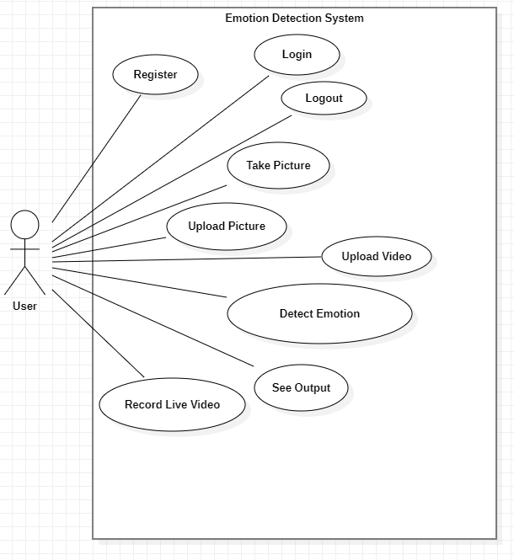

Figure 1 Use Case Diagram

### **4.2.2 Sequence Diagram for Emotion Detection System**

A sequence diagram provides a dynamic view of the system by depicting the interactions and sequences of messages between various components or objects. It shows how different parts of the system collaborate to achieve specific tasks.

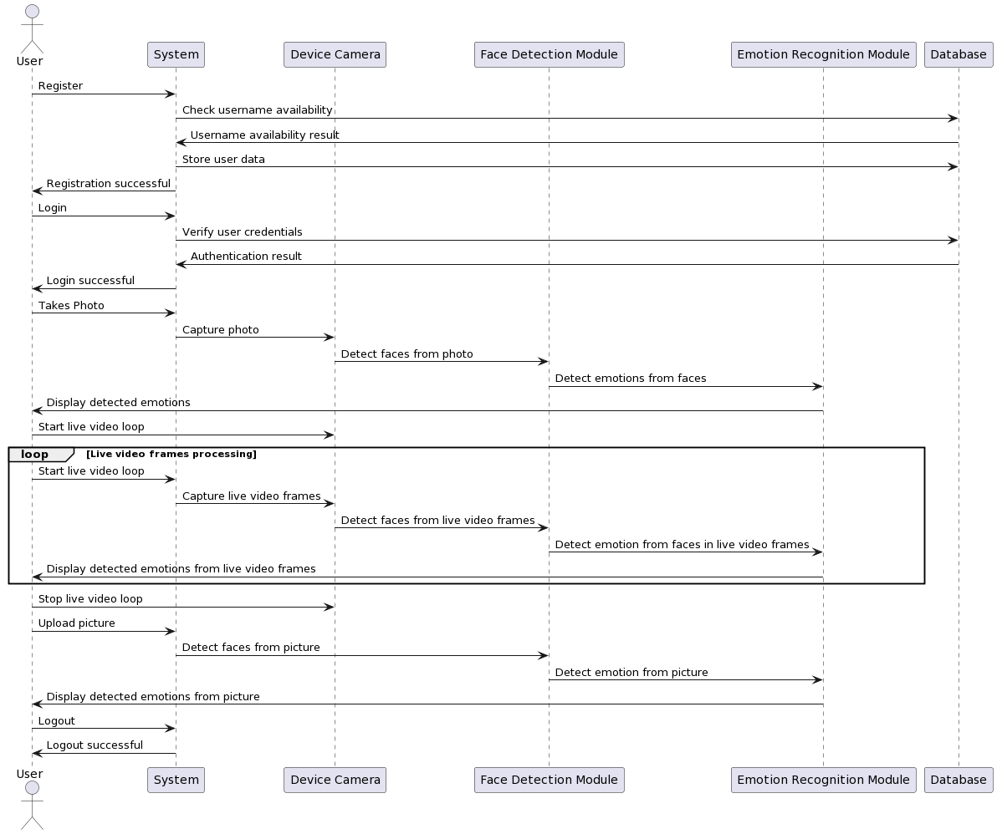

Figure 2 Sequence Diagram

In The above Sequence Diagram:

* The vertical lifelines represent the actors or objects involved in the interactions (User, Emotion Detection System, Database, Device Camera, and Emotion Recognition Module).
* Arrows and dashed lines represent messages and their sequence of exchange between the actors.
* Loops are used to indicate the continuous process of live video emotion detection.
* The diagram shows the flow of interactions and messages over time for each use case.

This Sequence Diagram provides a clear visualization of how the various components in the Emotion Detection System interact with each other and with the user during the specified use cases.

### **4.2.3 Entity Relational Diagram for Emotion Detection System**

An Entity-Relationship Diagram (ERD) is used to model the data structure and relationships within a database. It helps define the entities (tables), attributes, and their relationships in the system.

Entity-Relationship Diagram for Emotion Detection Database

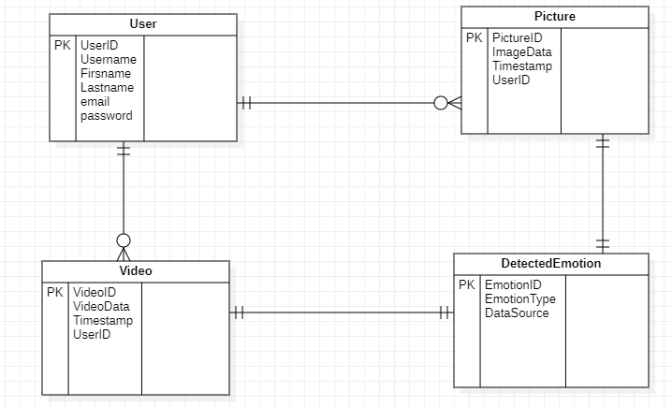

Figure 3 Entity Relational Diagram

Relationships:

* Each data entity has a one-to-many relationship with the Detected Emotion entity, indicating that one data source can have multiple detected emotions.
* The User entity has a one-to-many relationship with all data entities indicating that one user can have multiple data sources associated with their account.

### **4.2.4 Data flow Diagram for Emotion Detection System**

A Data Flow Diagram (DFD) is a graphical representation of the flow of data within a system. It illustrates how data is input, processed, and output by various components of the system.

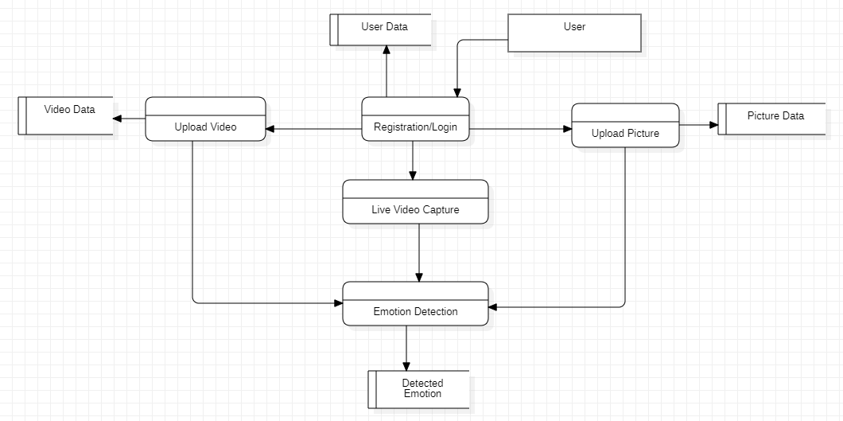

Figure 4 Data Flow Diagram

Data Flows:

* User Registration Data Flow: User provides registration data, which flows into the User Data store.
* User Login Data Flow: User provides login credentials, which are compared to the User Data store for authentication.
* Live Video Capture Data Flow: Live video data captured by the user flows.
* Picture Upload Data Flow: Uploaded pictures flow into the Picture Data store.
* Video Upload Data Flow: Uploaded videos flow into the Video Data store.
* Emotion Detection Data Flow: Data from Live Video Data, Picture Data, and Video Data stores are processed by the Emotion Detection process, and the results are stored in the Detected Emotions store. The detected emotions may also be displayed to the User.

## **4.3 System Development/Implementation**

A real-time emotional detection system's implementation phase is a crucial point in its development. This system uses algorithms to analyze user behavior and physiological information for accurate emotional recognition and uses a camera as a sensor. The development, hardware integration, testing, and deployment of the system are the primary subjects covered in this chapter, which also addresses the practical elements of implementation. The system can be implemented successfully, assuring its dependability, correctness, and usefulness, by using a systematic strategy.

### **4.3.1 Development**

Making well-informed judgments about the development framework and programming language to use, in accordance with the system's requirements and technical specifications, was one of the fundamental elements in developing an efficient emotional detection system. This preceded the development stage where essential software components were created. These modules included real-time video capturing and processing systems that effectively communicated with the camera sensor. Algorithms were carefully built to examine person behavior clues, such as head motions, eye closure patterns, and facial expressions, which were essential to the system's effectiveness. By seamlessly combining various software components, the integration process prioritized clear data flow and flawless synchronization, creating a harmonious and robust framework that held promise for powerful emotional detection and monitoring capabilities.

**Development Steps:**

**Installed the Required Software:**

Python, Django, React, and TensorFlow were installed on the system. These were obtained from their official websites or using package managers like pip for Python and npm for Node.js.

**Created a New Django Project:**

The django-admin startproject command was used to create a new Django project. This command generated a new directory with the project name, along with the necessary project files and folders.

**Created a New Django App:**

The python manage.py startapp command was utilized to create a new Django app within the project directory. This command established a new directory with the app name and initial app files and directories.

**Created a New React App:**

The npx create-react-app command was implemented to create a new React app within the project directory. This command created a dedicated directory for the React app and populated it with the required files and folders.

**Integrated React with Django:**

The Django project was configured to serve the React app as a static file. To achieve this, specific settings were added to the settings.py file, and a view that served the index.html file of the React app was created.

**Created the TensorFlow Model:**

A TensorFlow model designed to detect emotions based on user behavior and physiological data was developed or obtained. The option to use pre-trained models or train a custom model with relevant datasets was available.

**Integrated TensorFlow with Django:**

The TensorFlow model was integrated with the Django app by creating a view that received user data, processed it using the TensorFlow model, and returned the detected emotion.

### **4.3.2 Hardware Integration**

It was important to carefully consider the hardware components and their integration in order to develop a real-time emotion detection system. The first stage involved choosing a camera sensor that complied with the system's requirements, taking into account factors like resolution, frame rate, and compatibility. After selecting the appropriate sensor, the hardware setup procedure was initiated to ensure the correct mounting of the camera within the machine frame. Following this installation, a seamless communication interface was established, linking the camera sensor to the software components responsible for real-time data collection. Testing and configuring the camera sensor to optimize video quality while capturing essential facial features for emotion identification became the next crucial step. These hardware-related procedures were methodically handled by the structure itself.

**Hardware Integration Steps:**

**Selecting the Camera Sensor:**

The first step in hardware integration involved carefully selecting a camera sensor that met the system's technical requirements. Factors like resolution, frame rate, and compatibility with the system were considered.

**Hardware Setup and Mounting:**

Once the camera sensor was chosen, the hardware setup process was initiated to ensure the sensor's correct mounting within the machine frame. This step was critical to ensure proper data collection.

**Communication Interface:**

A seamless communication interface was created to connect the camera sensor to the software components responsible for real-time data collection. This ensured that data was transferred effectively between the hardware and software components.

**Testing and Configuration:**

The camera sensor was thoroughly tested and configured to optimize video quality. It was essential to capture facial features necessary for emotion identification with clarity and precision.

### **4.3.3 Testing and Validation**

The robustness and dependability of the developed emotional detection system were ensured through extensive testing. A comprehensive testing strategy encompassed multiple steps. Each software module and algorithm were meticulously examined, commencing with unit testing to ensure their validity and functionality. Subsequently, integration testing verified the efficient and seamless interaction between the camera sensor, software components, and data processing algorithms. A system-level test was performed to evaluate the overall effectiveness of the emotional detection system in a variety of circumstances. To assess the system's responsiveness and adaptability, a wide range of conditions were evaluated. Furthermore, the accuracy of the system was rigorously tested by comparing instances of identified emotions to known real-world data derived from reputable and trustworthy sources.

**Testing and Validation Steps:**

**Unit Testing:**

The testing process began with unit testing for each software module and algorithm. During this initial testing phase, the validity and functionality of individual components were verified, ensuring that they performed as intended.

**Integration Testing:**

Next, integration testing was conducted to assess the interaction between the camera sensor, software components, and data processing algorithms. This testing phase confirmed that these components worked together efficiently and without flaws.

**System-Level Testing:**

A system-level test was performed to evaluate the overall effectiveness of the emotional detection system in a variety of real-world scenarios. This test assessed the system's performance as a whole and its ability to adapt to diverse circumstances.

**Responsiveness and Adaptability Testing:**

The system's responsiveness and adaptability were evaluated under various conditions. This testing assessed how the system behaved and performed in typical and exceptional situations, ensuring its reliability in diverse scenarios.

**Accuracy Testing:**

The accuracy of the system was carefully tested by comparing instances of identified emotions to real-world data from reputable and trustworthy sources. This step helped ensure that the system's emotional detection capabilities were precise and aligned with known data.

## **4.3.4 Deployment**

A set of critical actions had to be taken as the system transitioned from development to real-world deployment to ensure its suitability for realistic emotional conditions. The physical installation of the camera sensor and related hardware components was carefully executed, with the components positioned within the machine to enable the best possible data gathering. Simultaneously, the software was set up and meticulously adapted to work with the intended platform. Conducting a thorough final system test was necessary at this crucial stage to validate the flawless communication between all system components. This comprehensive assessment served as a safeguard, ensuring that every aspect of the system operated without a hitch and successfully mitigated any potential problems that might have arisen during deployment. The system was fully prepared to thrive in a real-world environment.

**Deployment Steps:**

**Deployment on Heroku:**

The website was deployed on the Heroku platform. Heroku is a cloud platform that offers an easy way to host web applications. Ensure that all necessary configurations and dependencies are set up for Heroku compatibility.

**Software Setup:**

The software components were configured to run seamlessly on the Heroku platform. This includes setting environment variables and making any adjustments required for compatibility with the Heroku environment.

**System Testing:**

After deployment on Heroku, I conducted a final system test to ensure that the website runs smoothly in a live environment. Also, checked for any performance issues, responsiveness, and any platform-specific challenges.

**Quality Assurance:**

Quality assurance were also measured to identify and address any potential problems that may arise during Heroku deployment, ensuring the website functions reliably in real-world scenarios.

### **4.3.5 User Training and Support**

Thorough user training was required to enable the successful integration of the emotional detection system into real-world scenarios. This included a variety of strategies, starting with the production of instruction guides and learning materials. These materials explained how the system functioned, explained how to understand emotion alerts, and directed users in carrying out the right actions. A strong support system was put in place to further improve the user experience. It was skilled at handling user inquiries, providing prompt assistance, and supervising regular system maintenance and improvements. Through this all-encompassing strategy, end users were given the necessary information and tools, promoting effective use of the emotional detection system.

## **4.4 System Testing/Demonstration of The Output**

During the testing phase of the Emotion Detection System, various objectives were pursued to ensure the system's quality and reliability:

**Functional Testing:** Functional testing was achieved by systematically verifying that all features and functionalities of the system operated as designed. This involved creating test cases for each feature, performing test executions, and comparing the results against expected outcomes. Any discrepancies were thoroughly examined and corrected to ensure the system's core functions met their defined criteria.

**Integration Testing:** Integration testing was achieved by rigorously testing how the Emotion Detection System integrated with external dependencies and systems. The system's components were evaluated for compatibility and effective data exchange. Integration tests ensured that the system seamlessly communicated with external elements, including hardware sensors and data processing modules.

**Robustness Testing:** Robustness testing was achieved by subjecting the system to various real-world scenarios and exceptional circumstances. This involved introducing unexpected data inputs and evaluating the system's response. The system was validated to operate reliably even in less-than-ideal conditions and to handle unforeseen challenges effectively.

**Usability Testing:** Usability testing was achieved by involving real users in the testing process. Users interacted with the system to assess its user-friendliness and intuitiveness. Feedback from users helped refine the user interface and overall user experience, ensuring that the system was accessible and easy to use.

**Performance Testing:** Performance testing was achieved by simulating different workloads and conditions to evaluate the system's performance. This included stress testing to determine how the system handled high loads and responsiveness testing to measure response times. Scalability and resource utilization were assessed to ensure the system's performance met expectations.

**Security Testing:** Security testing was achieved by identifying vulnerabilities and weaknesses in the system's security safeguards. This included testing access controls, authentication procedures, and conducting penetration testing to identify potential security threats. Security measures were enhanced to protect user data and the system's integrity.

### **4.4.1 Test Scenarios**

Several test scenarios were identified and conducted to thoroughly assess the Emotion Detection System's functionality and performance:

* User Authentication: Verify that users can successfully register, log in, and log out of the Emotion Detection System.
* Data Validation: Validate that the system correctly handles user input data, including form validations and error messages.
* Selfie Capture and Emotion Detection: Test the core functionality of capturing a selfie and obtaining accurate emotion detection results.
* Live Video Emotion Detection: Evaluate the real-time emotion detection capabilities of the system during live video capture.
* Picture Upload and Emotion Detection: Verify that uploaded pictures are processed correctly, and emotions are detected accurately.
* Video Upload and Emotion Detection: Test the system's ability to process and detect emotions in uploaded video files.
* Error Handling: Examine the Emotion Detection System's error handling, including its response to errors, exceptions, and edge cases.

### **4.4.2 Test Cases**

Detailed test cases were created for each of the identified test scenarios to systematically verify the Emotion Detection System's behavior:

Table 1 Test Cases



## **4.5 System Interface**

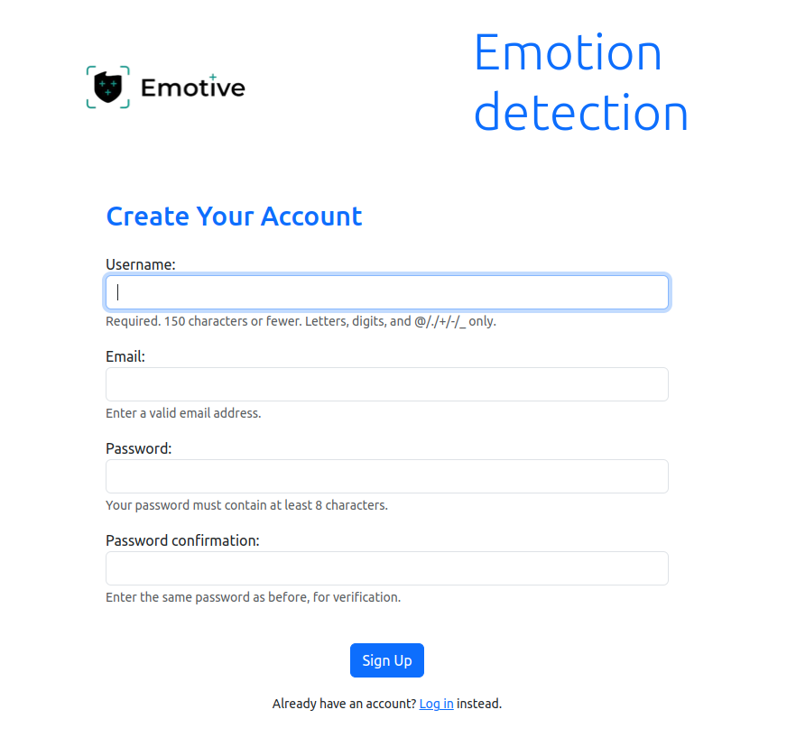

Figure 5 User Registration page

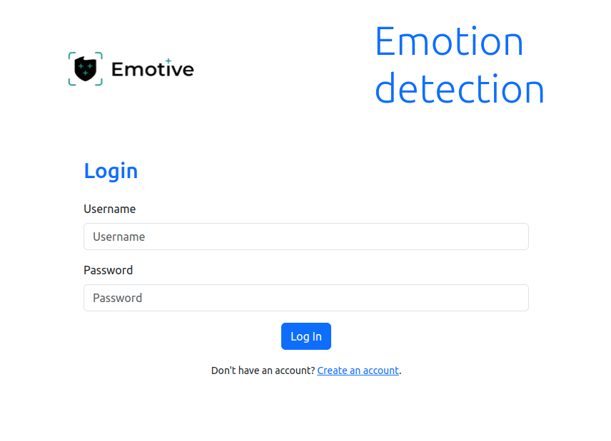

Figure 6 Login page

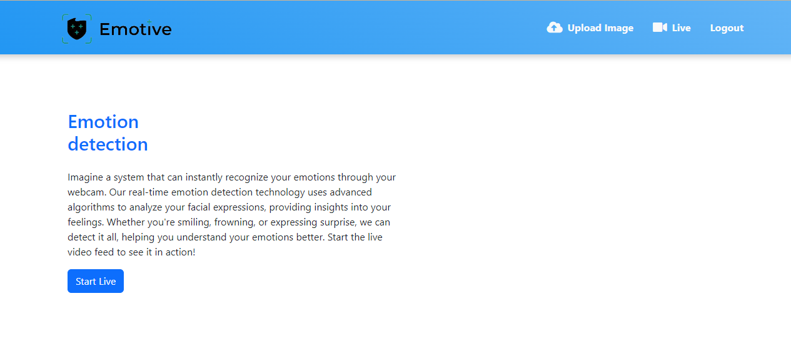

Figure 7 Image Upload and Live Video Emotion Detection page

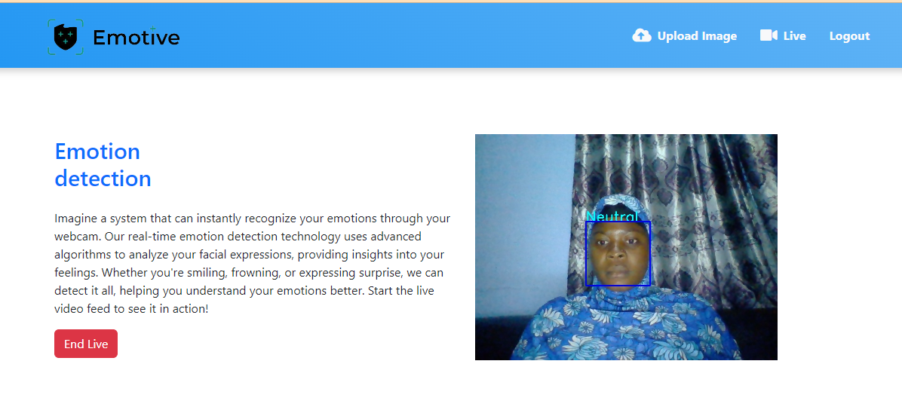

Figure 8 Live Video Emotion Detection

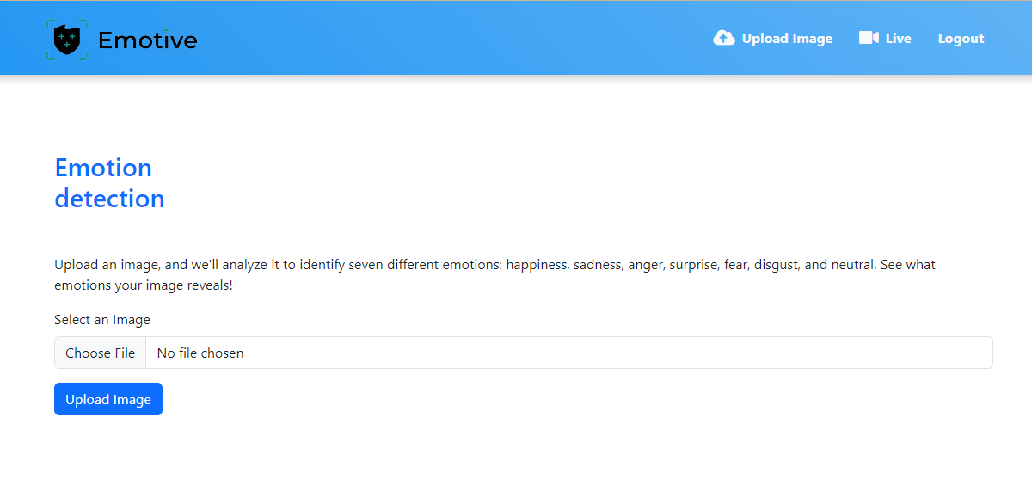

Figure 9 Image upload page



Figure 10 Analyzed Image 1

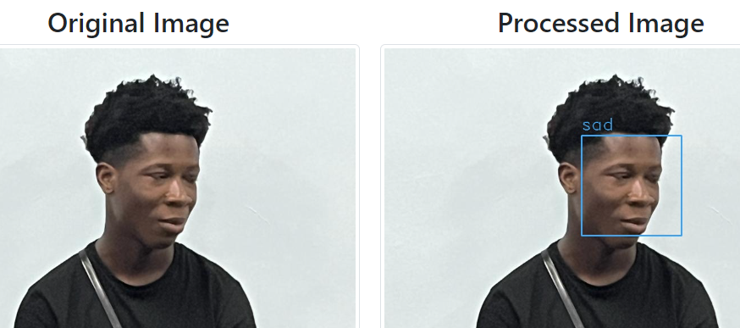

Figure 11 Analyzed Image 2

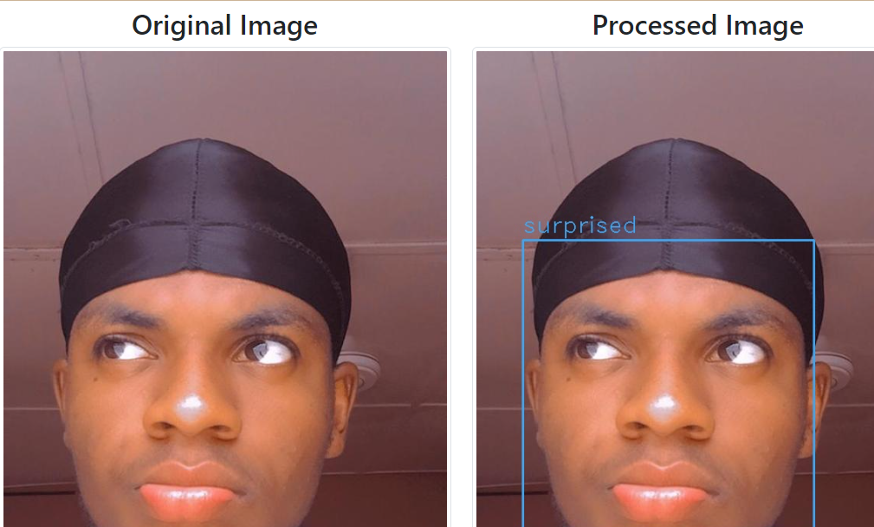

Figure 12 Analyzed Image 3

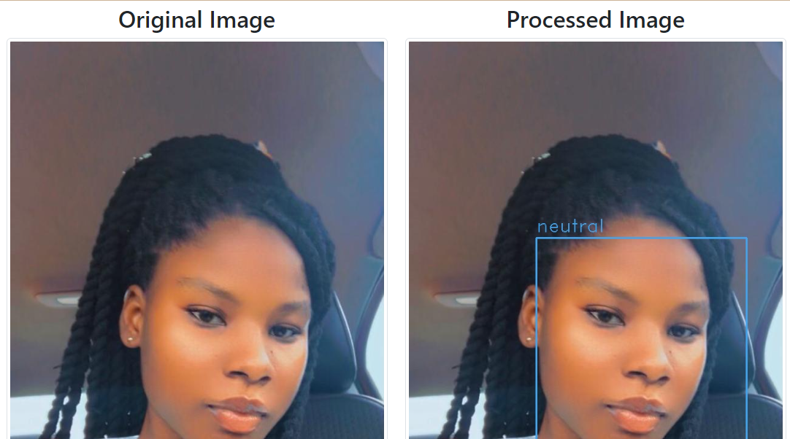

Figure 13 Analyzed Image 4

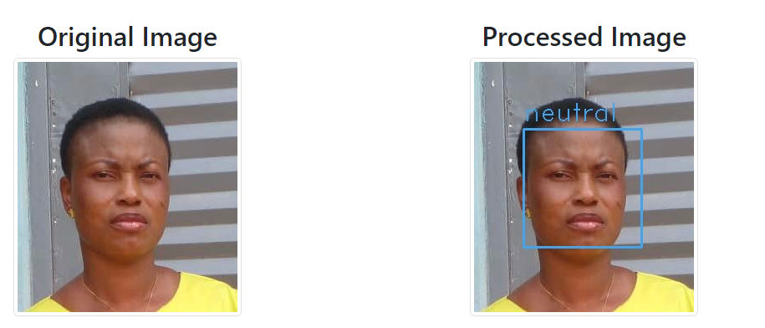

Figure 14 Analyzed Image 5

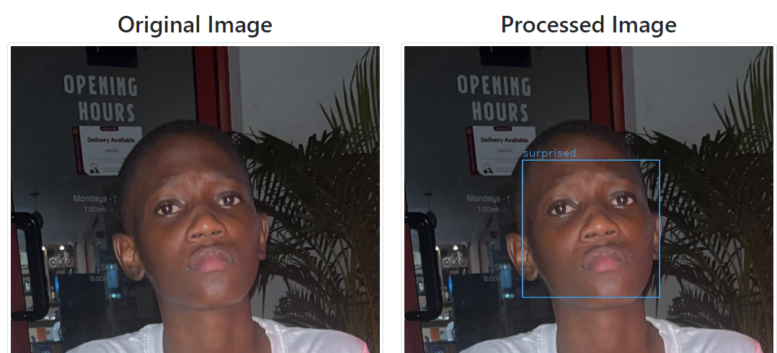

Figure 15 Analyzed Image 6

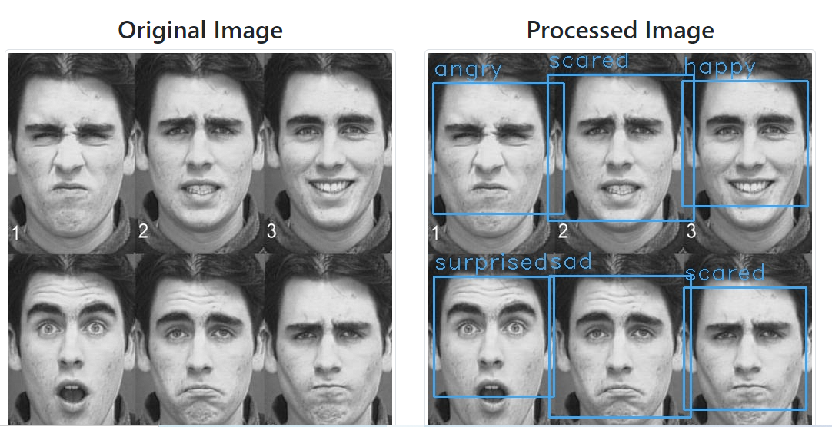

Figure 16 Analyzed Images 7

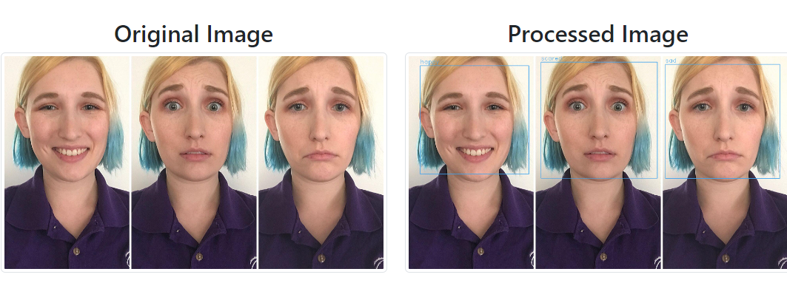

Figure 17 Analyzed Image 8

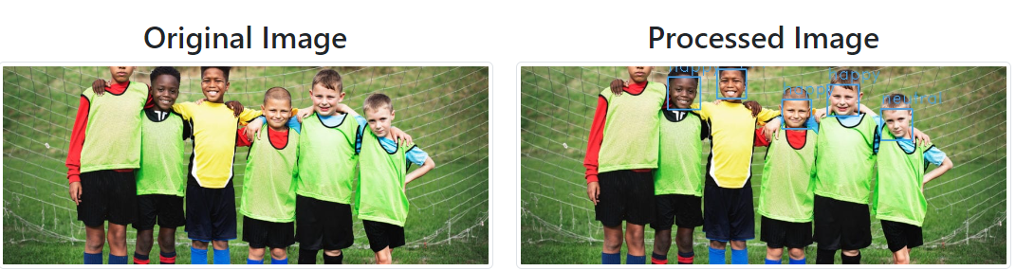

Figure 18 Analyzed Image 9

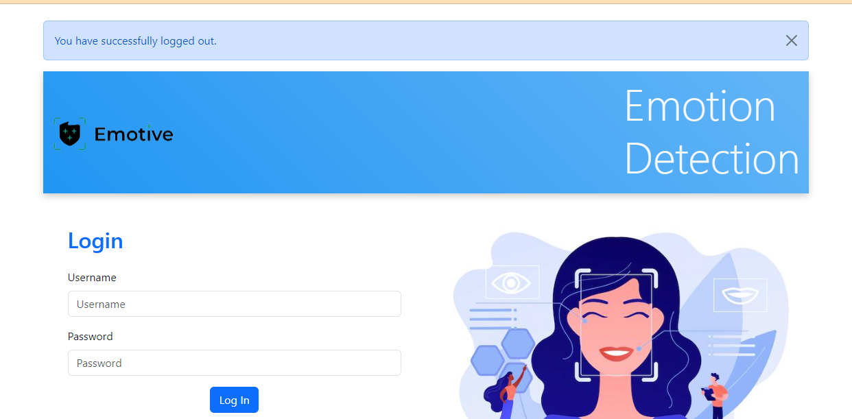

Figure 19 Successfully logged out

# **CHAPTER FIVE**

# **SUMMARY, CONCLUSION AND RECOMMENDATION**

## **5.0 Introduction**

A new era of human-computer interaction began in our constantly interconnected society, where digital technologies were seamlessly woven into every aspect of our everyday lives. This was due to the capability of computers to recognize and understand human emotions in real time. Real-time emotional detectors were at the vanguard of this technological transformation, supported by the powerful powers of deep learning and machine learning. These cutting-edge algorithms had the remarkable ability to interpret complex emotional language as it developed, providing a window into the very core of human expression.

Our knowledge of human emotions underwent a significant revolution as a result of the convergence of deep learning and machine learning. These systems progressed from being simple pattern recognition tools to complex models that could recognize and understand emotions in a variety of contexts using text, audio, facial expressions, and physiological inputs. From healthcare applications like mental health monitoring and patient care to marketing strategies tailored to customer sentiment analysis, from educational platforms that could adapt to students' emotional states to human-computer interfaces that responded empathetically to user needs, this evolution held immense potential across a variety of domains.

We explored the technical complexities that allowed these real-time emotional detectors to function so quickly and accurately. The algorithms that underpinned these systems were designed to process vast amounts of data and make sense of it within milliseconds. Neural networks, inspired by the human brain, played a pivotal role in analyzing emotional cues from various inputs. The training procedures for these algorithms involved exposing them to extensive datasets containing diverse emotional expressions, allowing them to adapt and improve their accuracy over time.

To achieve real-time emotional detection, these algorithms had to process data at remarkable speeds. They could analyze text in the blink of an eye, identifying nuances in word choice and sentence structure that indicated the underlying emotions. In the realm of audio, they could decipher tone, pitch, and intonation to discern not just what was being said but how it was being said. Facial expression analysis involved capturing minute muscle movements, and these detectors were able to swiftly interpret even the most subtle shifts in emotional expression. Moreover, physiological inputs like heart rate and skin conductivity were measured and interpreted in real-time, providing additional layers of insight into emotional states.

However, this journey also required us to address the more general implications and difficulties that came with the development of real-time emotional detection. Given that the effectiveness of these systems frequently depended on the use of personal data, privacy and consent issues were of major ethical importance. Striking the right balance between harnessing the power of these technologies and protecting individuals' privacy became a challenge. Ethical considerations urged us to ensure that these systems were used transparently and with the utmost respect for the data rights of individuals.

Additionally, there was a need to address the potential for bias and discrimination in these algorithms. Machine learning models are only as good as the data they are trained on, and if that data contains biases, the models can perpetuate and amplify these biases. This raised significant ethical concerns, highlighting the importance of continuous monitoring and refinement of these algorithms to minimize bias and discrimination in their outputs.

We examined both the opportunities and the obligations that came with real-time emotional detectors driven by machine learning and deep learning in the pages that followed. We looked into the programs that had the potential to transform how we communicate with one another and with technology. These systems held the promise of creating more intuitive and empathetic human-computer interactions, leading to a more seamless and responsive integration of technology into our daily lives.

This journey culminated in a comprehensive summary of key findings, followed by a thought-provoking conclusion. We concluded that the field of real-time emotional detection was poised for further growth and development, with vast potential to benefit society in numerous ways. It was clear that responsible and ethical development and deployment of these technologies were paramount. We offered a set of actionable recommendations for future research and application in this realm, emphasizing the need for ongoing ethical scrutiny, transparency, and a commitment to the betterment of society through the responsible use of real-time emotional detection technologies.

In closing, the journey we embarked on illuminated the transformative power of real-time emotional detectors, while also highlighting the ethical and societal challenges that must be navigated. With a commitment to ethical development and a clear understanding of the potential benefits and pitfalls, we can shape the future of human-computer interaction and emotional understanding in ways that enhance our lives while safeguarding our fundamental values and rights. As we move forward, it is essential to maintain a vigilant eye on the ethical and social implications, ensuring that these technological advancements continue to serve as tools for good.

# **5.1 Summary of Findings.**

The exploration of real-time emotional detection using machine learning and deep learning has yielded several significant findings:

1. Multimodal Emotion Recognition: The efficiency of multimodal techniques, which mix information from many sources including text, audio, facial expressions, and physiological signs, is one of the main conclusions. These methods perform better than single-modal models, providing more thorough and precise emotion identification.
2. Advancements in Deep Learning Architectures: According to research, deep learning architectures like Convolutional Neural Networks (CNNs) for image data, Recurrent Neural Networks (RNNs) for sequential data, and Transformer models for text data have greatly increased the accuracy and robustness of real-time emotion detection systems.
3. Transfer Learning and Pre-trained Models: Transfer learning, which involves pre-training models on big datasets and tuning them for particular emotion identification tasks, has grown to be a potent method. Natural language understanding and emotion analysis have been remarkably well-performed by trained models like BERT and GPT-3.
4. Real-World Applications: The results show a wide range of practical uses for real-time emotional detectors. These encompass technologies like virtual assistants, personalized marketing, adaptive education, human-computer interaction, and even self-driving cars that can adjust to the emotional states of the people within.
5. Challenges and Ethical Considerations: One of the foremost challenges that we have confronted is the issue of data security and privacy. To develop and deploy real-time emotion recognition software, it is essential to collect and analyze vast amounts of personal data. However, this inherently raises concerns about data security and the potential misuse of sensitive information. In response, our work has been guided by a commitment to safeguarding individuals' privacy rights. We have implemented robust data protection measures, encryption protocols, and strict access controls to ensure that the data we use is handled with the utmost care and responsibility. Our dedication to data security has been a fundamental principle throughout the development of our technology.
6. Human-Machine Collaboration: It has become clear that real-time emotional detectors work best when they work in conjunction with human knowledge. The precision and interpretability of these systems can be improved by fusing the capability of AI with knowledge from psychology and human behavior.
7. User Experience and Adaptability: User Experience and Adaptability have been pivotal aspects of our work in the development of emotional detection systems. The findings have underscored the critical importance of user-centered design in ensuring the success and ethical deployment of our technology.

User experience is central to the acceptance and effectiveness of any system that tracks and interprets human emotions in real-time. To this end, we have placed a strong emphasis on making users feel at ease and in control when their emotions are being tracked. In our work, we have prioritized the user's comfort and sense of agency throughout the entire interaction with our emotion detection system.

To create a positive user experience, we have strived to design user interfaces that are intuitive and user-friendly. We understand that complex algorithms underlie our technology, but for users, the interaction should be straightforward and approachable. Clear and understandable user interfaces have been a focal point in our development process, ensuring that users can easily engage with the system and understand how it works.

1. Real-Time Processing: Real-Time Processing capabilities are at the heart of our work in the field of emotional detection systems. The study findings have significantly influenced our approach, highlighting the paramount importance of real-time processing in various scenarios, especially when prompt responses and insights are essential.

In our work, we understand that real-time processing is not merely a convenience but a necessity in many applications. Whether it's for healthcare, customer service, or education, the ability to provide prompt answers and insights based on emotional data is crucial. This is particularly relevant in situations where immediate responses can make a significant difference in outcomes.

In conclusion, research into real-time emotional detection utilizing machine learning and deep learning has revealed how these technologies have the potential to revolutionize several sectors and enhance human-computer interactions. To ensure ethical and advantageous implementation, it has also highlighted the significance of addressing ethical issues, biases, and user experience. To realize their full potential, future research should concentrate on improving these technologies, making them more visible, and encouraging cooperation between AI and human knowledge.

# **5.2 Possible Applications of System**

There are several potential uses for real-time emotional detection systems employing machine learning and deep learning in numerous industries. The following are a few potential applications:

1. Mental Health Monitoring: These programs can assist in real-time mental health monitoring and provide assistance and intervention when indicators of stress, sadness, or anxiety are found. This is particularly helpful for distant mental health care and telehealth.
2. Personalized Marketing: By adapting marketing messages and adverts to the emotional states of specific customers, emotional analysis can boost consumer engagement and conversion rates.
3. Education and E-Learning: Adaptive learning systems can employ emotional detection to determine how engaged and frustrated students are, altering the level of content difficulty or adding more help as necessary.
4. Human-Computer Interaction: By enabling tools and programs to react to users' emotions, emotional detectors can improve human-computer interaction. Virtual assistants and chatbots, for instance, can modify their replies in reaction to the emotional cues of the user.
5. Customer Service: client service encounters can use real-time emotional analysis to recognize and address client emotions, resulting in more effective and compassionate help.
6. Autonomous Vehicles: To provide a relaxing and secure journey, emotion detection systems in autonomous vehicles can monitor the emotional states of the passengers. For instance, the car can modify the temperature, music, or lighting to suit the occupants' emotions.
7. Gaming: By adjusting gameplay, characters, and narratives in response to the player's emotional responses, emotion recognition can improve the gaming experience by enhancing immersion and engaging gameplay.
8. Security and Surveillance: Security and surveillance applications can use real-time emotional detectors to spot potentially suspicious or harmful behavior based on emotional indicators.

# **5.3 Conclusion**

In conclusion, a disruptive panorama of potential and problems is presented by real-time emotional detection enabled by machine learning and deep learning. These algorithms have shown to be very adept at understanding human emotions across a wide range of modalities, with applications ranging from personalized marketing to mental health care and beyond. But ethical issues with respect to confidentiality, equity, and the ethical use of personal data loom large, necessitating strong frameworks to safeguard individual rights. A healthy partnership between artificial intelligence and human knowledge is essential to effectively navigating this challenging terrain, ensuring that these systems are created with user-centered principles and transparency at their heart. As time goes on, a comprehensive strategy that strikes a balance between technological development and moral concerns will be essential for realizing the full potential of real-time emotional detection to enrich human experiences.

The fusion of advanced machine learning and deep learning with human insights offers a future in which our systems and devices not only comprehend our emotions but also react to them with empathy and accuracy. This journey towards emotionally intelligent technology. However, there are ethical obligations that go along with this revolutionary potential. We must traverse the challenges of data protection, bias mitigation, and user empowerment as we work to develop emotionally intelligent systems. We can direct the development of real-time emotional detectors towards a more compassionate and equitable technological landscape, where the advantages of artificial intelligence are harnessed for the greater good of society, by encouraging interdisciplinary collaboration, conducting rigorous research, and prioritizing ethical considerations.

# **5.4 Recommendation**

There are numerous main areas that demand focus for more study and development in the field of real-time emotional detection utilizing machine learning and deep learning. The following suggestion sticks out as this sector continues to develop:

Interdisciplinary Collaboration: Fostering multidisciplinary collaboration is essential to improving real-time emotional detection systems' precision, efficiency, and ethical concerns. More thorough and sympathetic systems may be created by bringing together professionals from disciplines including psychology, computer science, data ethics, and human-computer interaction. Such partnerships may guarantee that these technologies not only recognize emotions but also interpret them contextually, taking into account the nuanced and varied ways in which people express their feelings. This strategy would provide systems with more emotional intelligence that would benefit users in a variety of settings, from healthcare to customer service.

Insights into the emotional experience of people may be gained through collaboration between psychologists and data scientists, for example, leading to more precise emotion models. System design with openness, privacy, and justice in mind can be assisted by ethical experts. This multidisciplinary approach would make it easier to create standards and best practices for creating morally and responsibly minded real-time emotional detection systems. In the end, a multidisciplinary approach can result in more effective and compassionate technology that respects the various ways in which people express and feel their emotions.

# **References**

1. Abdullah, S. M. S. A., Ameen, S. Y. A., M. Sadeeq, M. A., & Zeebaree, S. (2021). Multimodal Emotion Recognition using Deep Learning. *Journal of Applied Science and Technology Trends*, *2*(02).
2. Akter, S., Prodhan, R. A., Pias, T. S., Eisenberg, D., & Fresneda Fernandez, J. (2022). M1M2: Deep-Learning-Based Real-Time Emotion Recognition from Neural Activity. *Sensors*, *22*(21). <https://doi.org/10.3390/s22218467>
3. Algarni, M., Saeed, F., Al-Hadhrami, T., Ghabban, F., & Al-Sarem, M. (2022). Deep Learning-Based Approach for Emotion Recognition Using Electroencephalography (EEG) Signals Using Bi-Directional Long Short-Term Memory (Bi-LSTM). Sensors, 22(8).<https://doi.org/10.3390/s22082976>
4. Alisawi, M., & Yalçin, N. (2023). INTELLIGENT METHODS IN ENGINEERING SCIENCES Real-Time Emotion Recognition Using Deep Learning Methods: Systematic Review. *Intelligent Methods in Engineering Sciences*, *2*(1), 5–021. <https://doi.org/10.58190/imiens.2023.7>
5. Anand M, & Dr. S. Babu. (2022). A Comprehensive Investigation on Emotional Detection in Deep Learning. *International Journal of Scientific Research in Computer Science, Engineering and Information Technology*.
6. Azam, N., Ahmad, T., & Haq, N. U. (2021). Automatic emotion recognition in healthcare data using supervised machine learning. *PeerJ Computer Science*, *7*. <https://doi.org/10.7717/PEERJ-CS.751>
7. Gannouni, S., Aledaily, A., Belwafi, K., & Aboalsamh, H. (2021). Emotion detection using electroencephalography signals and a zero-time windowing-based epoch estimation and relevant electrode identification. Scientific Reports, 11(1). <https://doi.org/10.1038/s41598-021-86345-5>.
8. Garcia-Garcia, J. M., Penichet, V. M. R., & Lozano, M. D. (2017). Emotion detection: A technology review. *ACM International Conference Proceeding Series*, *Part F131194*. <https://doi.org/10.1145/3123818.3123852>
9. Guo, J. (2022). Deep learning approach to text analysis for human emotion detection from big data. *Journal of Intelligent Systems*, *31*(1), 113–126. <https://doi.org/10.1515/jisys-2022-0001>
10. Hou, J. (2022). Deep Learning-Based Human Emotion Detection Framework Using Facial Expressions. *Journal of Interconnection Networks*, *22*. <https://doi.org/10.1142/S0219265921410188>
11. Jayaswal, R., & Dixit, M. (2020). Comparative analysis of human face recognition by traditional methods and deep learning in real-time environment. *Proceedings - 2020 IEEE 9th International Conference on Communication Systems and Network Technologies, CSNT 2020*. <https://doi.org/10.1109/CSNT48778.2020.9115779>
12. Kamiri, J., & Mariga, G. (2021). Research Methods in Machine Learning: A Content Analysis. *International Journal of Computer and Information Technology (2279-0764)*, *10*(2).<https://doi.org/10.24203/ijcit.v10i2.79>
13. Kaur, M., & Kaur, J. (2019). Facial Expression Recognition Using Deep Learning Methods. In Advances in Intelligent Systems and Computing (Vol. 816, pp. 1-10). Springer. <https://ieeexplore.ieee.org/document/9154121>.
14. Kumar, A., & Singh, R. (2022). Deep Learning and Machine Learning based Facial Emotion Detection using CNN. In 2022 9th International Conference on Computing for Sustainable Global Development (INDIACom) (pp. 1-6). IEEE. <https://ieeexplore.ieee.org/document/9763165/>
15. Lu, X. (2022). Deep Learning Based Emotion Recognition and Visualization of Figural Representation. *Frontiers in Psychology*, *12*.<https://doi.org/10.3389/fpsyg.2021.818833>
16. Mellouk, W., & Handouzi, W. (2020). Facial emotion recognition using deep learning: Review and insights. *Procedia Computer Science*, *175*, 689–694. <https://doi.org/10.1016/j.procs.2020.07.101>
17. Nandwani, P., & Verma, R. (2021). A review on sentiment analysis and emotion detection from text. In *Social Network Analysis and Mining* (Vol. 11, Issue 1). Springer. <https://doi.org/10.1007/s13278-021-00776-6>
18. Siam, A. I., Soliman, N. F., Algarni, A. D., Abd El-Samie, F. E., & Sedik, A. (2022). Deploying Machine Learning Techniques for Human Emotion Detection. Computational Intelligence and Neuroscience, 2022. <https://doi.org/10.1155/2022/8032673>
19. Singh, S. K., Thakur, R. K., Kumar, S., & Anand, R. (2022). Deep Learning and Machine Learning based Facial Emotion Detection using CNN. *Proceedings of the 2022 9th International Conference on Computing for Sustainable Global Development, INDIACom 2022*. <https://doi.org/10.23919/INDIACom54597.2022.9763165>
20. Xu, J., Hu, Z., Zou, J., & Bi, A. (2020). Intelligent Emotion Detection Method Based on Deep Learning in Medical and Health Data. *IEEE Access*, *8*. <https://doi.org/10.1109/ACCESS.2019.2961139>

# **APPENDIX A**

**Program Codes for the main program**

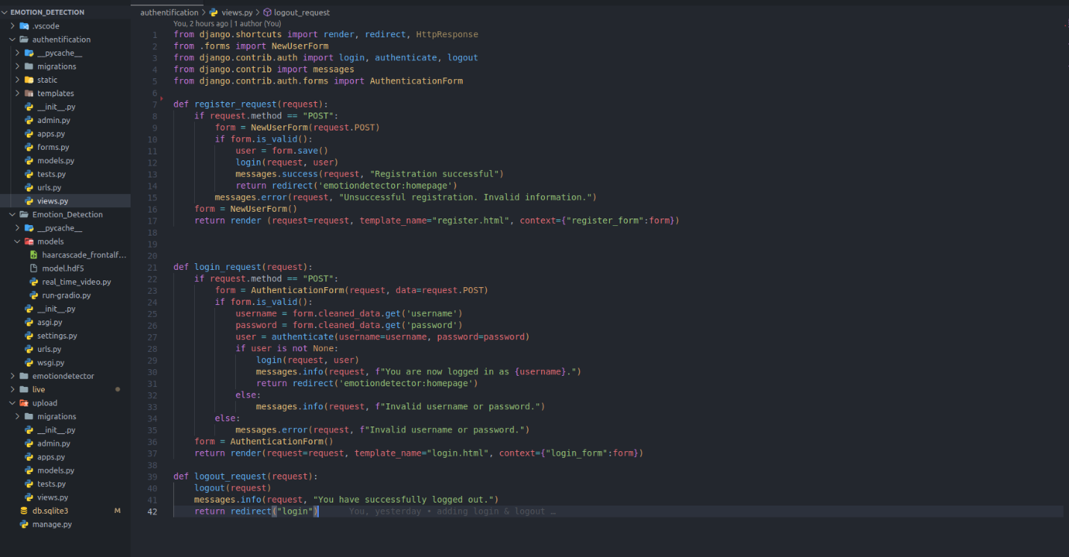

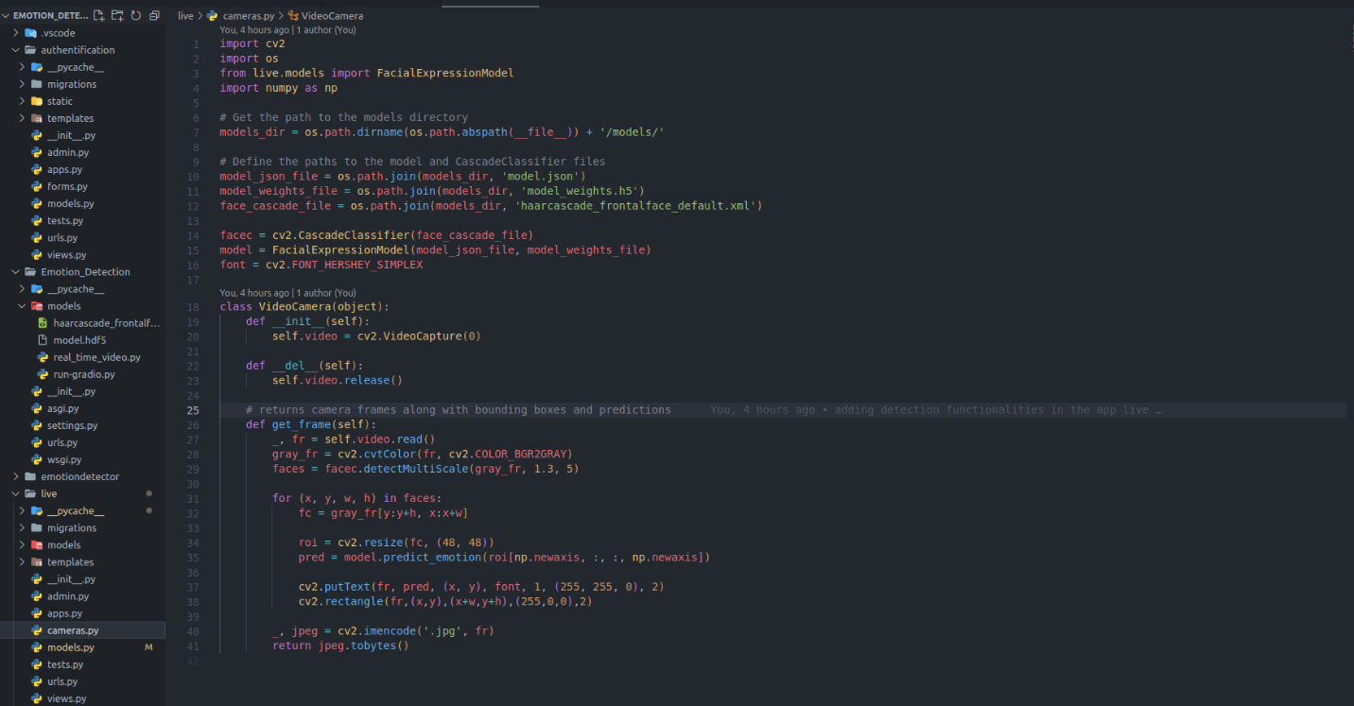

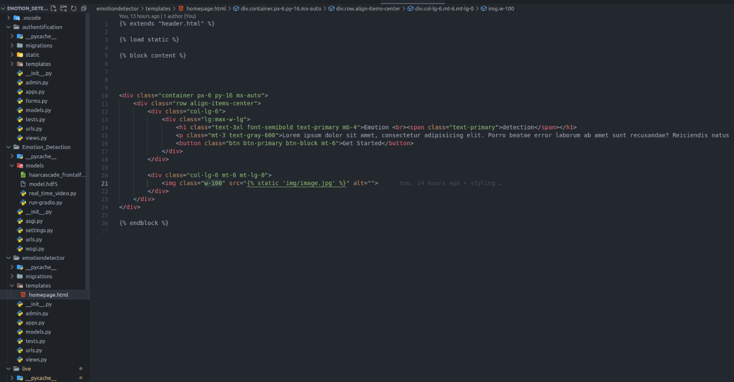

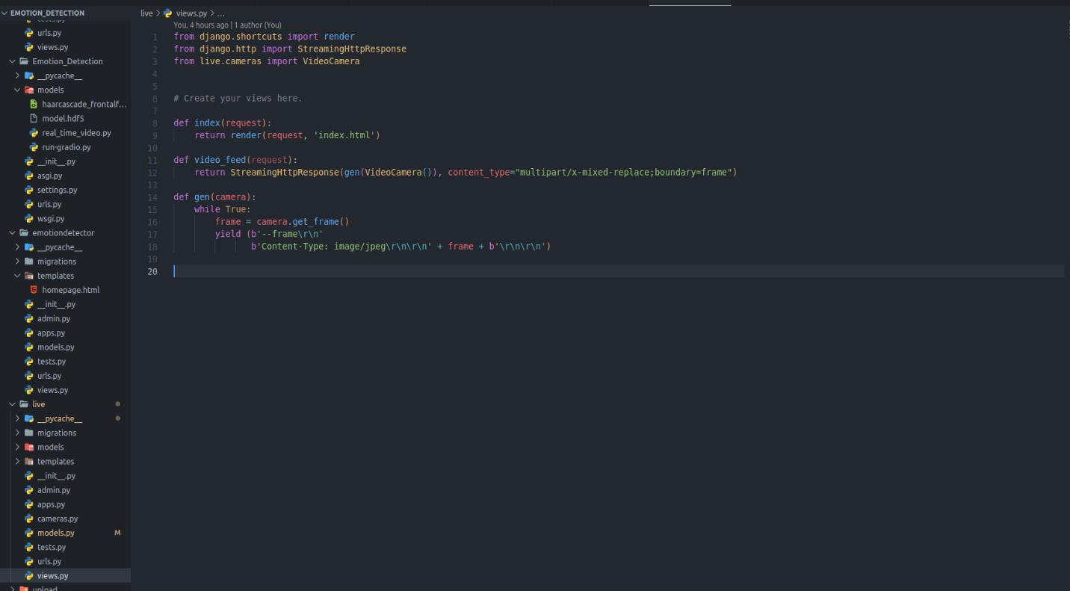

# **APPENDIX B**

**User interfaces of the application**













